Wk 10

Exploding stars point to a young universe

Where are all the supernova remnants?¹
by Jonathan Sarfati
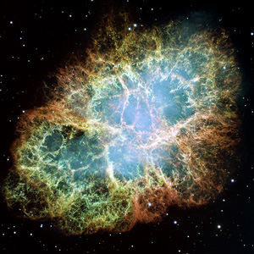Supernovas. A mega-explosion in space. Some of these have been seen from the earth. The Crab Nebula here as it is today, is the remnant of a supernova which was seen in the year 1054 AD and remained visible to the naked eye for about a year. Credit: NASA
A supernova,² or violently exploding star, is one of the most brilliant and powerful objects in God’s vast cosmos. On average, a galaxy like our own, the Milky Way, should produce one supernova every 25 years.
Click for 214k Supernova image, (courtesy NASA)
When a star has exploded in this way, the huge expanding cloud of debris is called a SuperNova Remnant (SNR). A well-known example is the Crab Nebula in the constellation of Taurus, produced by a supernova so bright that it could be seen during daytime for a few weeks in 1054. By applying physical laws (and using powerful computers), astronomers can predict what should happen to this cloud.
According to their model, the SNR should reach a diameter of about 300 light years³ after 120,000 years. So if our galaxy was billions of years old, we should be able to observe many SNRs this size. But if our galaxy is 6,000–10,000 years old, no SNRs would have had time to reach this size. So the number of observed SNRs of a particular size is an excellent test of whether the galaxy is old or young. In fact, the results are consistent with a universe thousands of years old, but are a puzzle if the universe has existed for billions of years. The conclusions can be seen from the simple table shown below:
Supernova  Remnant Stage | Number of observable SNRs predicted if our galaxy were… |  | Number of SNRs actually observed
 | … billions of years old | … 7000 years old
First | 2 | 2 | 5
Second | 2260 | 125 | 200
Third | 5000 | 0 | 0
As can be readily seen above, a young universe model fits the data of the low number of observed SNRs. If the universe was really billions of years old, there are 7000 missing SNRs in our galaxy.
Not only that, but the predictions for the Milky Way’s satellite galaxy, the Large Magellanic Cloud are also consistent with a young universe. Theory predicts 340 observable SNRs if the LMC were billions of years old, and 24 if it were 7000 years old. The number of actually observed SNRs in the LMC is 29. [See Detailed discussion and calculations]
As the evolutionist astronomers Clark and Caswell say, ‘Why have the large number of expected remnants not been detected?’ and these authors refer to ‘The mystery of the missing remnants’.⁴
There should be no mystery—Psalm 19:1 says: ‘The heavens declare the glory of God; and the firmament sheweth his handiwork.’ Supernovas declare His mighty power, but are still only finite expressions. The low number of their remnants is a pointer to God’s recent creation of the heavens and earth.

How do supernovas happen?
An ordinary star is a gigantic ball of gas, about a million times more massive than the earth—our sun is a medium-sized star. It is potentially stable for a long time, because the energy produced by the core produces an enormous outward pressure, which balances the inward force of gravity on its huge mass.
However, when the nuclear fuel runs out, there is no longer any force to balance its gravity. If the star is very massive, most of it collapses very fast — in about two seconds. This releases a huge amount of energy—one supernova will out-shine all the billions of stars in its galaxy. The collapse is so violent that the electrons and nuclei are crushed together and produce a core of neutrons. This core is so dense that a teaspoonful would weigh 50 thousand million tons on earth. It cannot be compressed any further, so the incoming material from the rest of the star meets a solid wall. This material bounces off the core, rushes outward and shines very brightly. The remaining core, only about 20 km in diameter, is called a neutron star. Because it is spinning very fast, and has a strong magnetic field, we observe regular radio pulses, so the object is called a pulsar.
The energy produced by a supernova is mind-boggling: 10⁴⁴ joules. It is the same as if each and every gram of the earth’s mass was converted to a nuclear bomb 200 times more powerful than the one dropped on Hiroshima. That amount of energy would fuel 80 million sun-like stars for 100 years!

Detailed discussion and calculations
A widely-accepted model of supernova expansion predicts three stages:
1) The first stage starts with debris hurtling outwards at 7000 kilometres per second. After the material has expanded for about 300 years, a blast wave forms, ending the first stage. By this time it reaches a diameter of about 7 light years.⁵ This is an immense object—about 25,000 times larger than our solar system, which is ‘only’ about eight light hours across (about 8600 million km or 5400 million miles).
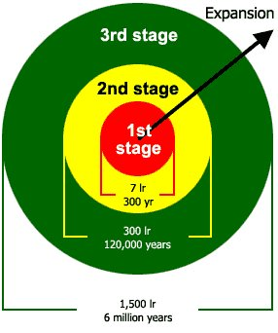The three predicted stages of supernova development
Since the first stage should last about 300 years and one SNR should occur every 25 years, there should now be 300/25 first stage SNRs in our galaxy, or about 12. We should not expect to see them all—astronomers calculate that only about 19% of SNRs should be visible,⁶ that is about two of the 12. It makes no difference whether the universe is thousands of years old as the Bible indicates, or billions of years old as evolutionary theory asserts. Actually we see five first stage SNRs (this is within the uncertainty range of the calculation).
2) The second stage SNR, known as the adiabatic⁷ or Sedov stage, is a very powerful emitter of radio waves. This is predicted to expand for about 120,000 years and reach a diameter of about 350 light years. After this, it starts to lose thermal (heat) energy and begin the third stage. Now, if the universe was billions of years old, we would predict (remember, one supernova every 25 years, and taking into account SNRs in the 300-year first stage) that in our galaxy there would be about (120,000–300)/25 second stage SNRs, or about 4800. But if the universe has only existed for about 7000 years, then there would be only enough time for (7000–300)/25, or about 270. Astronomers calculate that 47% should be visible, so evolutionary/uniformitarian theory predicts about 2260 second stage SNRs, while the Biblical Creation theory predicts about 125. The actual observed number of second stage SNRs is a good test of which theory best fits the facts.
There are actually only 200 second stage SNRs observed in our galaxy! This is in the right ball park for Biblical creation, but is totally different from evolutionary predictions. Evolutionists at present have no answer to the problem of the missing supernova remnants.
3) The third, or isothermal,⁸ stage is theorised to emit mainly heat energy. This stage would theoretically only start after 120,000 years, and would last about one million to six million years. The SNR would end its career when it either collided with similar SNRs at a diameter of about 1400 light years, or became so dispersed that it would be indistinguishable from the ֹvacuum’ of space at a diameter of about 1800 light years.
One calculation makes the generous (to evolutionary theory) assumption that the third stage starts at about 120,000 years and a diameter of about 340 light years, and lasts to an age of one million years and 650 light years. Thus if the universe was billions of years old, there should be (1,000,000–120,000)/25 third stage SNRs in our galaxy, or about 35,000. Of these, about 14% should be observable, or about 5000. However, if the universe is only about 7000 years old, no SNR should be old enough to have reached the third stage, so there should be absolutely none, under currently accepted models. This is another test of the two theories, an old vs. a young universe.
There are actually no third stage SNRs observed in our galaxy!

How can distant starlight reach us in just 6,000 years?
by Mark Harwood
Image Wikipedia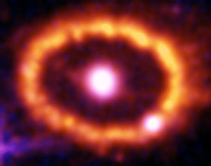Supernova
The following question was received from JD in response to one of the World by Design presentations in Australia recently, after I had earlier answered orally on the Hobart part of the World By Design tour.
“God is not a man that He should lie, nor a son of man that He should change His mind.” (Numbers 23:19, NIV)
The above Scripture reference summarizes the essential trustworthiness of God. In view of this, if the entire universe (and not just the earth) was created approximately 6,000 years ago, how do you understand such events as, for example, supernova 1987A, in which a star exploded at a distance of approximately 170,000 light years from the solar system?
The astronomical distance scale is of course not absolute, but there is little basis for believing it to be overestimated by a factor of about 30 at such a relatively close distance. Other astronomical observations appear to represent vastly more distant objects, seen therefore at a much earlier epoch.
To suggest that the entire observable universe was created with a history of events (that never actually occurred) seems to be inconsistent with the character of the God described in the Bible.
I will now address each of the issues in the order in which JD has raised them:
“God is not a man that He should lie, nor a son of man that He should change His mind.” (Numbers 23:19, NIV)
The above Scripture reference summarizes the essential trustworthiness of God.
Indeed, and it is God’s trustworthiness that provided the basis for the study and development of science in the first place and is why science developed in cultures that held a Judeo-Christian worldview (See the first chapter of Refuting Evolution by J Sarfati). Also, God’s trustworthiness provides the basis for our understanding of the perspicuity of Scripture, that is, the belief that it was written to be understood and that God would not deceive or mislead us. The plain meaning of the opening chapters of Genesis can, therefore, be taken as an historical account of what actually happened during the Creation Week, the Fall, the Flood and the dispersion at the Tower of Babel.
Of course, it doesn’t follow that statements made by fallible people based on their observations of the physical world are necessarily valid or trustworthy.
In view of this, if the entire universe (and not just the earth) was created approximately 6,000 years ago, how do you understand such events as, for example, supernova 1987A, in which a star exploded at a distance of approximately 170,000 light years from the solar system?
The supernova 1987A was observed in 1987 (hence its name) and is generally accepted as being 170,000 light years away (See also this article which includes a section on supernova 1987A). On the surface, it would appear that the light has been travelling for 170,000 years which is not consistent with a 6,000 year old universe. But the question is, by which clocks is the time being measured?
The astronomical distance scale is of course not absolute, but there is little basis for believing it to be overestimated by a factor of about 30 at such a relatively close distance. Other astronomical observations appear to represent vastly more distant objects, seen therefore at a much earlier epoch.
Big bangers have exactly the same problem. That is, the background radiation temperature is almost uniform, …. However, there hasn’t been nearly enough time for [energy transfer] to occur even in the assumed time since the alleged big bang
It’s interesting to note that big bangers have exactly the same problem. That is, the background radiation temperature is almost uniform, to one part in 100,000, at about 2.725 K, even when we look in the opposite directions of the cosmos. Since the big bang would predict hugely different temperatures, how did they become so even? Only if energy was transferred from hot parts to cold parts. However, there hasn’t been nearly enough time for this to occur even in the assumed time since the alleged big bang—see the instructive article Light-travel time: a problem for the big bang by Ph.D. astrophysicist Jason Lisle.
The misotheistic publication New Scientist admitted in 13 things that do not make sense (19 March 2005, updated 14 April 2009):
This “horizon problem” is a big headache for cosmologists, so big that they have come up with some pretty wild solutions. “Inflation”, for example. You can solve the horizon problem by having the universe expand ultra-fast for a time, just after the big bang, blowing up by a factor of 10⁵⁰ in 10⁻³³ seconds. But is that just wishful thinking?
Other big bangers have tried to cure this headache by proposing that the speed of light was much faster in the past, e.g. João Magueijo and John Barrow. Yet when some creationists proposed something similar a few decades ago, it was a heresy! I.e. anything goes when it comes to rescuing the big bang dogma, but rescuing Genesis by exactly the same means is verboten. However, the observations of uniformity in the cosmic background radiation, which defy plausible evolutionary explanations, are consistent with a single Creator of space and time who holds the universe together (Colossians 1:17).
To suggest that the entire observable universe was created with a history of events (that never actually occurred) seems to be inconsistent with the character of the God described in the Bible.
Image NASA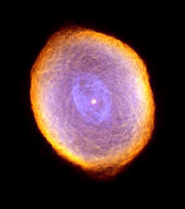Nebula
Agreed. One idea which has been put forward to address this problem is that God created the information about such events in the ‘light’ beam on its way to Earth. However, this would imply a deceptive act by God if the event had never actually occurred. Most creationists would not support this idea. (See Alex Williams and John Hartnett, Functional creation and the appearance of age, pages 168–173 in: Dismantling the Big Bang.)
Recent developments in creationist cosmology offer an elegant explanation of the distant starlight question which is consistent with the Genesis account of creation and is based on recent astronomical observations and Einstein’s General Relativity equations. Whilst a detailed explanation of this new cosmology is beyond the scope of this Feedback article, it is explained more fully in the book Starlight, Time and the New Physics by John Hartnett. Hartnett’s explanation is an extrapolation from General Relativity, based on the expansion of the universe and 5D (space-time-velocity) Cosmological General Relativity as developed by Carmeli. One of the powerful confirming aspects of this cosmology is that the highly speculative big bang concepts of dark matter and dark energy are not required to explain the observations made in the far reaches of the cosmos—see Has dark matter really been proven?
Another model, also based on General Relativity, developed by Russell Humphreys explores gravitational time dilation and is explained in his DVD called Light-Years? No Problem!
This article attempts to provide a framework for understanding the answer to the distant starlight question. The key elements are time dilation, the recent observations showing that we live in a galacto-centric universe and the Scriptural references to God ‘stretching out the heavens’ on Day 4 of the Creation Week.

Time dilation
An experimentally verified prediction of Einstein’s General Relativity Theory is a phenomenon called gravitational time dilation. It has long been established that gravity affects the rate at which time flows in any particular location in the universe. A graphic example of this phenomenon is the GPS satellite navigation system which is becoming a standard feature in many motor vehicles today.
It has long been established that gravity affects the rate at which time flows in any particular location in the universe. A graphic example of this phenomenon is the GPS satellite navigation system which is becoming a standard feature in many motor vehicles today.
One’s position is determined by comparing the time taken for signals from a number of the satellites, which are visible at any one time, to reach the receiver so very high precision timing is needed. The constellation of satellites orbits the earth at an altitude of about 20,000km. At this height, the atomic clocks on board the satellites run faster than the same clocks on earth by 42 microseconds per day. The satellites are travelling at around 12,000 km per hour which produces an opposing relativistic effect of slowing the clocks down by about 5 microseconds per day. The combined effect is that the clocks on the GPS satellites run 38 microseconds per day faster than equivalent earth-bound clocks. Why does this matter? If this time difference was ignored and no compensation made, the position errors would build up at a rate of about 400m per hour which would render the system completely useless!
Another mechanism for time dilation is rapid acceleration of the fabric of space in an expanding universe. This is explained more fully in Hartnett’s book referenced above.

We live in a galactocentric universe
When Edwin Hubble discovered the redshift in the spectra of stars and galaxies and interpreted them as distance (known as the Hubble Law), he was horrified at the implication that the Earth could be in a special place.
Standard big bang theory has it that the universe has neither a centre nor an edge which is an assumption, called the Cosmological Principle, designed to avoid the earth being a special place. If the Earth was special in any way, it would imply design and thus a Designer which flies in the face of atheistic evolutionary belief. When Edwin Hubble discovered the redshift in the spectra of stars and galaxies and interpreted them as distance (known as the Hubble Law), he was horrified at the implication that the Earth could be in a special place. He wrote:
‘Such a condition [red shifts] would imply that we occupy a unique position in the universe … But the unwelcome supposition of a favoured location must be avoided at all costs … [and] is intolerable … moreover, it represents a discrepancy with the theory because the theory postulates homogeneity.’¹
In fact, Hubble in his later works rejected the velocity interpretation of the redshift, and instead preferred ideas such as ‘tired light’, to reject the big bang and expanding universe in favour of an infinite stationary one.²
Recent surveys^{3,4} have measured the galactic redshift for around 250,000 galaxies and have revealed an over abundance of galaxies at certain redshifts in which the data departs from the expected theoretical distribution in a series of large spikes. A straightforward interpretation of this data is that the galaxies are distributed with a spherical shell-like symmetry with the Milky Way galaxy at or near the centre! Such a result is entirely consistent with the biblical picture but is at odds with standard big bang beliefs and is not consistent with the Cosmological Principle.

God stretched out the heavens
In at least 11 places, the Scriptures speak of God ‘stretching out the heavens’ (e.g. Job 9:8, Isaiah 40:22 and 42:5, Jeremiah 10:12, Zechariah 12:1) and in Genesis 1:15 the words ‘And it was so.’ are recorded in connection with the events of Day 4 of Creation Week, implying the completion of the events described on that Day. It is a reasonable conclusion to draw that God stretched out the heavens to the vast extent of the observable universe in just one 24 hour day and then ceased the action of ‘stretching out’. This is more rational than the inflation fudge of big bangers discussed above. That is, where the universe just happened to expand much faster than light, although there is no known physical cause for starting or stopping this superluminal expansion.
We should also note that God created the Earth first before the sun, moon and stars (and by inference the planets etc) so it would seem reasonable to assume the universe was stretched out with the Earth at or very near its centre. Furthermore, Psalm 147:4 and Isaiah 40:26 imply that there is a finite number of stars in the universe. So, the Bible seems to teach that we live in a finite universe that has, at the very least, our Milky Way galaxy at its centre.

Distant starlight and the biblical timescale
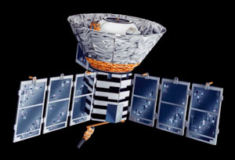Artist’s impression of the COBE satellite.
We now have the keys to understanding how starlight can reach us from such vast distances in just a few thousand years of Earth time. The days of the Creation Week were recorded from the point of view of an observer on the earth so the time reference in Genesis is Earth time. On Day 4, as God commenced stretching out the heavens, the mass of the universe (presumably including the ‘waters above’ which were separated out on Day 2) would have been confined to a much smaller volume of space than is the case today. Assuming the Hartnett–Carmeli theory is correct, the Universe rapidly expanded with massive time dilation as a result of very rapid acceleration of the fabric of space on Day 4. The Humphreys model⁵ on the other hand, also based on General Relativity, has clocks at the outer edge of the cosmos running much faster than earth-bound clocks because of gravitational time dilation.
By the end of Day 4, when God completed his work of creating the sun, moon and stars, and had stretched out the heavens to their vast extent, billions of years of cosmic time could have elapsed at the outer edges of the cosmos in just one 24 hour earth day. There would have been more than enough time for the light from distant stars to have reached the earth so that when Adam gazed at the night sky on that sixth night he would have seen much the same as what we see today.
6,000 years have passed since the Creation Week. If the models outlined above are correct, the light we see today from any star that is greater than 6,000 light years away from the earth will have originated on Day 4 itself. This would include most of the visible stars, all of which are part of the Milky Way galaxy. We are effectively looking at God’s creative activity on Day 4 as we gaze into the universe!
So what do we make of supernova 1987A? At 170,000 light years away we are looking at an event that occurred on Day 4 but whose light did not reach us until 1987.
Is an exploding star consistent with a perfect creation? God said that the stars were created to be for signs and seasons (Genesis 1:14) and God foreknew all that would happen right from the very beginning. What to us seems to be destruction is actually just a physical process which does not necessarily denote any lack of perfection in the original creation. Importantly, there is no loss of biblical life involved (the creatures affected by death brought about by the Fall were those the Bible calls נֶפֶשׁ חַיָּה (nephesh chayyāh)).⁶

Distant starlight and the days of Genesis 1

NASA/JPL-Caltech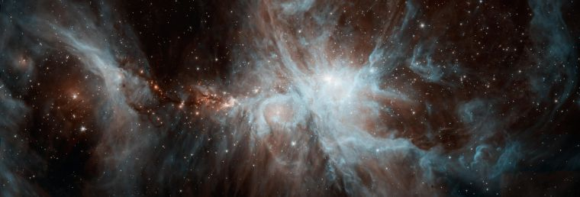The Orion Nebula
How should we approach the distant starlight travel time issue? How do we argue against day-age theory? CMI’s Shaun Doyle examines these questions in today’s feedback from William L. from Australia.
Dear William,
Thank you for your email and your kind words. As a general point, I recommend our search function and our Q and A pages, by which you can find articles that answer all these questions.
NASA, ESA, and The Hubble Heritage Team (STScI/AURA); Acknowledgment: J. Gallagher (University of Wisconsin), M. Mountain (STScI), and P. Puxley (National Science Foundation)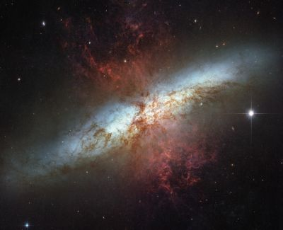Messier-82 galaxy
Dear CMI,
I’m a huge fan of your work and I appreciate all that the organisation has done in strengthening the faith of many Christians worldwide.
I just have a few questions on starlight, scripture and Dr. Humphreys’ theory.
1) The speed of light is related to a number of physical constants. E.g. E = mc² and c² = 1/ε₀µ₀ (Deriving the speed of light with Maxwell’s equations). Hence, changing the speed of light will change the energy levels of atoms, atomic and nuclear constants (classical electron radius will change, if energy was kept constant then mass of electron and proton will have to change) and the electric and magnetic constants (ε₀ and µ₀). This leads to the question: how do you reconcile a faster speed of light in the past (and the change should be substantial to allow light to travel ~ 13 billion lightyrs from the farthest galaxy to the earth in 6000 yrs) with the Anthropic principle which includes the argument that all the physical constants of the universe can’t be changed by a fraction (as that would mean that man will not be able to exist)?
We don’t have to reconcile the two because we do not currently advocate any sort of idea that postulates a faster speed of light in the past to explain distant starlight, nor does Dr Humphreys. Please see How can we see distant stars in a young Universe?
2) I read the section in your book ‘refuting compromise’ about why it is wrong to interpret each day in Genesis as one of God’s days (or a long period of time). Please correct me if I’m wrong but it seems that the main argument is that because there is a number associated with the word ‘day’ in Hebrew (yom), therefore, the Hebrew language does not allow the long period of time interpretation for the word. But I was wondering, if we were to translate the verse in Peter’s letter about how 1 day can be a 1000 years to God from Greek into Hebrew, wouldn’t it be a Hebrew instance where even if there is a number associated with the word ‘yom’, that ‘yom’ could still be a long period of time?
This is what Dr Sarfati says:
“When modified by a cardinal number (for example, one, two, three …) or ordinal number (for example, first, second, third …) as used 359 times in the OT [Old Testament] outside Genesis 1, yôm always means a literal day of about 24 hours, or the light portion of the day-night cycle. This is true in narrative, legal writings, prophecy, wisdom literature, and even poetry. So there must be extraordinary reasons to justify an extraordinary exception, if Genesis 1 is indeed an exception.”¹
Understanding the point of 2 Peter 3:8 still depends on understanding ‘day’ as a typical 24-hour day
He of course goes on to demonstrate that Genesis 1 is no exception to this unanimous usage, and not just by appealing to this pattern (he cites other evidence in favour of his interpretation). But this argument is inductive—he is establishing a general pattern from specific examples. He is saying that in every actual example of the ‘yôm + number’ construction in the Old Testament yôm always refers either to a 24-hour day or the daylight hours of a 24-hour day. Instead, your question misconstrued Dr Sarfati’s argument as deductive—explaining a particular example by a general rule; i.e. that there is an inviolable rule in Hebrew grammar that says: “yôm +number can only refer to a 24-hour ‘day’”. There is of course no such inviolable rule. But this doesn’t matter for Dr Sarfati’s argument because his argument is inductive, not deductive.
Concerning 2 Peter 3:8 (also covered in Refuting Compromise), note the second half of the verse: “and a thousand years are like a day”. And note 2 Peter 3:9: “The Lord is not slow to fulfill his promise as some count slowness, but is patient toward you, not wishing that any should perish, but that all should reach repentance.” Peter is expanding on Psalm 90:4 to show that some people’s idea of ‘slow’ is wrong. God’s promise will be fulfilled in due time, and the so-called ‘slowness’ doesn’t demonstrate the falsehood of the promise, but demonstrates God’s patience. In all this, understanding the point of 2 Peter 3:8 still depends on understanding ‘day’ as a typical 24-hour day. Note also that these verses have nothing to do with the days of Genesis 1.
Please see 2 Peter 3:8—‘one day is like a thousand years’, Did God really take six days?, The meaning of yôm in Genesis 1:1–2:4, and The days of Creation: A semantic approach.
3) I read in one of your books or heard in your videos that CMI believes that the universe was in existence in Gen 1:1–2. How old was the universe just before the 1st day?
Genesis 1:1–2 was not before the first day, but describes the starting conditions of the cosmos on the first day. Referring to the Sabbath, Exodus 31:17 says: “It is a sign forever between me and the people of Israel that in six days the Lord made heaven and earth, and on the seventh day he rested and was refreshed.” Everything was made in those first six days of history, including the initial state of the universe from nothing (that was actually the beginning of the first day). Please see ‘Soft’ gap sophistry.
4) In Dr. Humphreys’ theory, he argues that because of the deformation in the space-time fabric and the expanding universe, time ran faster on the edge of the universe compared with time at the location of the Earth. Hence, billions of years could pass at the edge of the universe in 4 earth days. But doesn’t that mean that the universe itself is still billions of years old (at least on the outer limits of the universe)?
We don’t need to know how distant starlight got to Earth in a single Earth day to know that it did.
What matters for Dr Humphreys’ cosmology (and others like it) is that only one day passed on earth while billions of years’ worth of physical processes occurred on the outer reaches of the universe. In a relativistic sense we could say that the universe is both 6000 years old (as measured on Earth) and billions of years old (as measured at the edge of the universe). However, the Bible counts time from an earth-bound reference frame, so it speaks of the universe being about 6,000 years old. Please see How can we see distant stars in a young Universe?
Note that all creationist cosmologies seek to do is try to understand how distant starlight got to Earth in a single Earth day. They are not seeking to discern whether that happened. That question is easily settled—it happened. That God is omnipotent clearly means God can do it, and Genesis 1:14–19 clearly implies that it happened. We just don’t know how it happened. But we don’t need to know how distant starlight got to Earth in a single Earth day to know that it did.
Nevertheless, it is good to try and figure out how it happened, or at least develop plausible theories on how it could have happened given the observational data we have. It shows we think Genesis 1 occurred in the real space-time-matter world, and is not some ‘religious’ idea that has nothing to do with the real world. It also shows that the observational evidence really is consistent with Genesis 1. And it shows we’re not against science per se. Please see Modern science in creationist thinking.
Thanks CMI for your help. You answers will be very much appreciated.
Kind regards and God Bless,
William
Kind regards,
Shaun Doyle
Creation Ministries International

The apparent age of the time dilated universe

Explaining the missing intracluster media in globular clusters
iStockphoto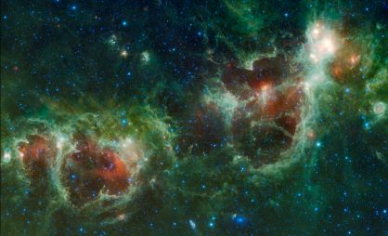
by Ronald G. Samec
In creation time dilation cosmologies (e.g. Humphreys and Hartnett), while the earth experiences less than 10,000 years of recorded history (God’s time clock), millions, and possibly billions, of years pass in the distant universe.
In these models, one of the major questions is “What is the maximum apparent age that should be used to characterize the universe?” Should we accept the apparent age of the universe of 13.82 x10⁹ years as determined by the European Space Agency based on the recent PLANCK space telescope results?^{1,2} As mentioned in the previous paper by the author,³ astronomical dating schemes are corrupted by the assumption that the age of the sun is 4.57 x 10⁹ years. I call this the Solar Age Condition (SAC). This age is determined from radioisotope ages of ‘primordial meteors’. We now know that RATE results completely discredit this age. We are no longer bound to accept the pronouncements of the evolutionary cosmological community.
Globular clusters should have much higher dust and gas accumulations than observed.
Therefore, we seek alternative Natural Chronometers such as Humphreys’ spiral wind-up time or helium diffusion rates! Our quest is to find natural reference clocks (NRCs) like Newtonian orbital periods, the speed of light, and other well-known, well-observed physical rates or frequencies accepted by scientists, worldwide, to determine the apparent age of the time dilated universe.
Globular clusters (GCs), are spherically shaped rich assemblages of stars (usually 50,000 to millions of solar masses) that orbit their galaxies at random inclinations and eccentricities, much like comet orbits in the solar system. One of the best examples of globular clusters in the northern hemisphere is M13, located in the Keystone asterism of the constellation of Hercules (figure 1). A much larger assemblage is found in the southern skies, denoted Omega Centauri because it appears as a star to the unaided eye.
Diagram: Bill Snyder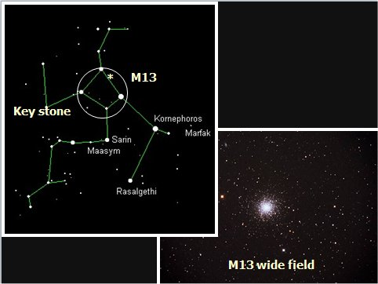Figure 1. M13 is a prominent globular cluster found in northern hemisphere skies in the constellation of Hercules in the ‘Keystone’ asterism.
GCs roughly form a spherical distribution component in the galaxy, which is called the Halo. GCs are red (high colour index), high-velocity population II or ‘POP II’ objects. POP II objects include novae, RR Lyrae stars, and red giants, as well as GCs.
They are not associated with dust and gas, as are the Pop I objects which make up the disk of the galaxy. They have a ‘metalicity’ of less than 1% (metalicity is the abundance of elements more massive than helium). Population I and II objects differ in their orbits. POP I objects are disk population objects (figure 2).
GCs are readily seen in images of spiral and elliptical galaxies as what appears to be still images of stars ‘swarming’ about the galaxy like fire flies. Of course, individual stars cannot be seen at this distance, but the GCs, made up of many thousands of stars in a compact arrangement, are clearly visible. Observations of these objects reveal they are true to their specified population. They are clear of intracluster medium (ICM); that is, dust and gas.
A major problem is easily identified. Individual stars, as they age, blow off stellar winds of gas and dust.
Therefore, GCs as well as their ‘twins’, the dwarf spheroidal galaxies that orbit as companions to their parent galaxies, should accumulate dust and gas steadily from these winds. ICM should accumulate in the clusters. But both objects are POP II. There is a physical inconsistency here. It is hypothesized that these clusters regularly purge their ICM by crossing the dense galactic disk. According to Moore and Bildsten (M&B), the “most robust mechanism for clearing ICM is ram pressure stripping during disk crossings”.⁴ This is proposed as the primary means that the GC remains a POP II object. But this plane passage occurs about every 10⁸–10⁹ years! Our NRC here is derived from the well-known Newtonian/Keplerian orbital equation,
Individual stars, as they age, blow off stellar winds of gas and dust.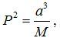
where P is the orbital period, a the orbital semimajor axis and M is the central mass. From this, we find that crossings are too far and few between! In the meantime, between disk crossings, the ICM is accumulating, and, on the average, most of the galaxies’ globular clusters should have much gas and dust, in disagreement with their POP II status! What do the observations tell us? Infrared Spitzer observations place upper bounds on dust masses 10–100 times lower than expected,^{5,6} exactly like its POP II counterparts. M&B summarize the problem:
“Observations of the intra-cluster medium (ICM) in galactic globular clusters (GCs) show a systematic deficiency in ICM mass as compared to that expected from accumulation of stellar winds in the time available between galactic plane crossings.”
Globular clusters should have much higher dust and gas accumulations than observed. Where is the missing ICM in globular clusters? M&B try to solve this major problem by further hypothesizing that globular clusters lose their ICM by outflows from outbursts of classical novae in the cluster.

What are classical novae?
A classical nova is a binary star consisting of a white dwarf (a compact core from a star that has lost its atmosphere) and a normal star companion which has filled its critical surface (called a Roche lobe) and is streaming gas (hydrogen) toward the white dwarf (WD). The stream spirals in and creates a disk of gas. As the disk increases in density, the stream collides with the now opaque disk and produces a hot spot. The inner disk eventually funnels the gas onto the surface of the WD and accumulates hydrogen gas on it. The temperature of the gas rises as the pressure increases and eventually the hydrogen ignites in a thermonuclear runaway—a nova outburst occurs. This causes a fast outflow of gas at about 1,000 km/s.
Diagram: Bill Snyder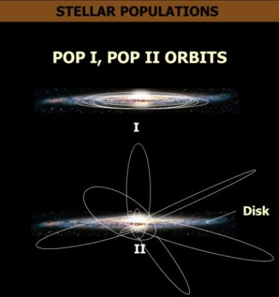Figure 2. Population I and Population II objects differ in their orbits. Pop I objects are largely disk population while Population II objects form the Halo of spiral galaxies.
The rate of occurrence of novae outbursts in a GC is quite variable and is not well known. M&B assumed a rate of 20/year/10¹¹ solar masses in the cluster. Further study shows more massive clusters will have a clearing problem due to ‘runaway’ accumulations to ICM between novae outbursts—their clearing mechanism seems only to work well in low-mass GCs. Their hopeful remark is, “A very robust mechanism to clear the ICM is Type Ia Supernovae.” Of course we have been discussing novae here and not super novae! Super novae are some 11 magnitudes brighter than novae and eject matter at 10,000 km/s! Certainly super novae would help things along, but they are very, very rare indeed! They are 500 times rarer than M&B’s assumed rate!
In a recent study of the occurrence of type 1a supernovae in GCs, not a single SN1a supernova was found to have occurred in any of the 36 clusters studied in the archival observations!⁶

Creation perspective
If the ICM is 1/10 to 1/100 the amount expected, as determined by the observations, and plane crossings are 10⁸–10⁹ years apart, our NRC gives a range of age limits of the globular clusters of only 10⁶–10⁸ years, similar to the apparent (time dilation) age predicted for spiral galaxies to wind up and lose their ‘spiralness’ (see Humphreys⁷). This is much less than the 13.82 x 10⁹ years given by cosmologists for the age of the cosmos (100th to 10,000th of this age!). A simpler explanation is that clusters have not been orbiting long enough to accumulate much ICM! We have other evidence that the universe is young, and that the actual age in ‘earth time’ is only about 7,000 years. This means that GCs actually have only 1/10³–1/10⁴ times the expected amount of ICM so they would fulfill their POP II status quite well.⁸
According to these considerations and to Scripture, the apparent age of the cosmos is much lower than the ‘astronomical’ age assumed by the cosmologists:⁹ “For in six days the LORD made heaven and earth, the sea, and all that in them is, and rested the seventh day” (Exodus 20:11).

Does the new much-faster-speed-of-light theory fix the big bang’s problems?
by John G. Hartnett
wikimedia commons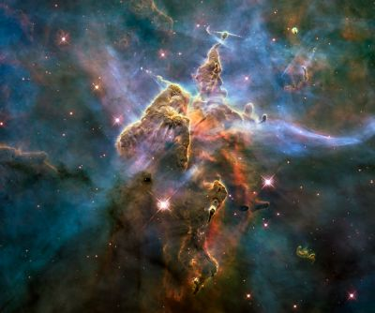Carina Nebula
A recent paper¹ by Niayesh Afshordi and João Magueijo asserts that they have discovered a testable cosmology wherein during a “critical” cosmological phase of the early universe the maximal speed of propagation of matter (and hence light) was enormously much faster than the current speed of light (c) and faster than the speed of gravity, which in Einstein’s theory is the canonical speed c.
They revisit what has become to be known as varying speed of light (VSL) models, in contrast to the now popular cosmic inflation models. They believe light traveled much faster just after the big bang than it does now and have developed a mathematical model of a big bang universe only a miniscule fraction of a second after the alleged hot beginning of the universe.
The big bang model has many problems, but the biggest and most difficult to solve is what is known as the ‘horizon problem’.² Cosmic inflation has been invoked to solve this problem. Afshordi and Magueijo agree that,
Cosmologists believe that structure in the universe was seeded from initial density variations in the early universe.
… the Big Bang model of the Universe remains an unfinished work of art. Many of its late-time successes can be traced to the initial conditions postulated for its early stages, and these are put in by hand, without justification, other than to retrofit the data. The main culprit for this shortcoming is the so-called horizon problem: the cosmological structures we observe today span scales that lay outside the ever-shrinking “horizons” of physical contact that plagued the early universe. This precludes a causal explanation for their initial conditions.¹ (emphases added)
Cosmologists believe that structure in the universe was seeded from initial density variations in the early universe. But for structures (clusters of galaxies, for example) to naturalistically form gravity must propagate over the scale of any structure in the timescale available to it at the past epoch when the structures were allegedly built.
In addition we observe a uniform temperature across all the sky in the cosmic microwave background (CMB) radiation, yet sources on opposite sides of the observable universe have not had time to exchange energy, at the constant speed of light c, in the time available in the big bang universe. That is, they have not had the time to come into thermal equilibrium. These limitations are what are known as ‘horizons’.
The major problem with the big bang model is that cosmic inflation scenarios are inserted by hand, to overcome these ‘horizons’ but without any justification for why inflation started and why it stopped. Quite obviously if the speed of light were infinite there would exist no such ‘horizon’ to thermal equilibration of the universe.
Various extensions to the big bang model have been proposed to overcome the horizon problems. Some proposals include an early accelerated expansion, a contracting phase followed by a bounce, a loitering early stage, and others a varying speed of light (VSL).
Afshordi and Magueijo:
None of these proposals evades the criticism that retrofitting the data is still used to select in detail the primordial fluctuations that the model should produce. Once primordial causal contact is established, work can start on concrete physical mechanisms for spoiling perfect homogeneity (e.g. vacuum quantum fluctuations or thermal fluctuations). Typically it is found that one can produce a wide range of initial conditions including, but not circumscribed to those explaining the observations.¹ (emphases added)
Various extensions to the big bang model have been proposed to overcome the horizon problems.
So the problem to date has been not what one would call prediction but retro- or post-diction. The result is known and the desired effect is put in by hand. Because cosmologists believe that the CMB radiation is leftover radiation from the early big bang universe, they also believe that the CMB temperature variations across various physical scales are representative of density variations in the early universe across those scales. By choosing a ΛCDM big bang cosmology³ they believe that they can ‘wind the clock back’ to some early stages of the big bang universe. (Note the circular reasoning in that alone.)
Typically they have used the precise measurements of temperature fluctuations (called anisotropies) in the CMB radiation to determine a power spectrum for those fluctuations—that quantifies the amplitude of density variations over various spatial scales. Those fluctuations can be quantified by a number called a spectral index n_{S} from the power spectrum. The spectral index n_{S} measurements within a certain range are claimed to indicate the validity of cosmic inflation.⁴ The range of inflation models limit the allowed value of this number.
Its value is interpreted to be related to early stage density fluctuations and as you might imagine the speed of sound in the early big bang universe is important to how those density fluctuations might have propagated.
Therefore the speed of sound, which must be always less than the speed of light, is an important factor. If the speed of light is allowed to go to infinity then also the speed of sound can too. The Afshordi–Magueijo model involves a fast-phase transition in the speed of sound, when the universe was very small, which leads to thermal fluctuations consistent with the measurement of n_{S} from the CMB radiation.
Therefore, the speed of sound, which must be always less than the speed of light, is an important factor.
Believing that the CMB does represent the oldest light in the universe—i.e. from the big bang fireball—Afshordi and Magueijo now also believe their theory can be tested using future observations of CMB radiation. They assert that light travelled at an infinite speed following the big bang, before slowing down to what we define as the speed of light, c, today (which is about 300,000 km/s or 186,000 miles/s). This much faster speed of light in the early universe then allegedly explains the uniform temperature of the CMB radiation seen in all directions around earth, i.e. overcoming that ‘horizon’ problem, but not of the formation-of-structure ‘horizon’ (homogeneity and isotropy problems) because the speed of gravity is still c.
Their “critical cosmological model makes an unambiguous, non-tuned prediction for the spectral index of the scalar fluctuations: n_{S} = 0.96478(64).”¹ This value lies very much within the latest determination of the spectral index from the 2015 Planck satellite data⁵ (determined from CMB temperature fluctuations and an assumed cosmology) yet the authors are somewhat more circumspect.
The fact that its main prediction (for n_{S}) lies spot in the middle of the Planck results should not beguile us into a false sense of security. Improved observations will soon vindicate or disprove this model.¹
They could disprove their model but they cannot prove their model. This is the basis of science—disproof, never proof. Yet there still remains other problems that their proposal does not solve.
One may wonder about the status in our model of the other cosmological problems, such as the flatness, homogeneity and isotropy problems.¹
The near infinite speed only pertains to massless matter (including light) but not gravity (gravitons travel at speed c). Except for flatness (the model requires exact flatness) the other cosmological problems are not solved by this new proposal. However the authors believe that their VSL model can solve them and deferred to a later paper in preparation.
However the main point in the new paper is that the authors claim their new model is testable.⁶ Operational science is based on the principle of repeatable testability. The question here is: Is their cosmology (or any cosmology) actually testable in an operational science sense?
The answer is an unequivocal no!
The reason for this is that the authors cannot interact with the universe, which is what they really are wanting to test their model against. They may look for nullification of the spectral index against some future CMB data, which needs to improve in precision by at least 100 times. But even if it were found that some future improved result was tightly bound within their prediction, does it prove that the universe had the history they claim their model describes? No, it does not. This is because one cannot rule out all other models (including those not yet even dreamed up) that produce the same result. Cosmology in this case is not a repeatable science. I would even go so far as to say it is not really even science.⁷
Operational science is based on the principle of repeatable testability.
The reason I say this is because even to generate the spectral index data one needs to assume a cosmology. Then there are a plethora of models, some of which may ‘predict’ the same value of certain parameters, most of which are derived this way.
I suggest, in fact, that the reason so many dark entities (dark matter, dark energy, dark radiation, dark photons, etc) are now suggested to get various theories to fit observational data is because the underlying theory—the big bang cosmology—is a bad theory for the structure and origin of the universe.⁸
The big bang never happened. The CMB radiation is real enough but to link it with a fictitious big bang fireball is a form of one’s belief system determining how to interpret the observational data.
Besides evidence exists to suggest that the CMB radiation is not even primordial (not the oldest light in the universe).⁹ Therefore if it is not from the big bang, how can any parameter related to its spectral density of temperature fluctuations be descriptive of the fictitious event?

Confirmed: physical association between parent galaxies and quasar families
by John Hartnett
iStockphoto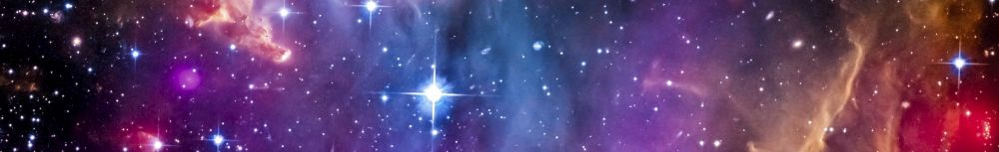
In a paper just published¹ that looked for an association between putative parent galaxies and pairs of quasars,^{2,3,4} the authors found many such quasar families, suggesting that the association is real, and not just coincidental. They used the Sloan Digital Sky Survey (SDSS) data release 7 and the 2MASS (Two Micron All Sky Survey) Redshift Survey (2MRS) Ks ≤ 11.75 mag data release to test for the physical association of candidate companion quasars with putative parent galaxies by virtue of Karlsson periodicity in quasar redshifts.
This means that to a very high probability, much higher than a random association, certain quasars are physically associated with lower redshift galaxies.
Karlsson proposed that quasars have an intrinsic non-cosmological redshift component which comes in discrete values (z_{K} = 0.060, 0.302, 0.598, 0.963, 1.410, …). However, to properly detect any physical association, the candidate quasar redshift must be transformed into the rest frame of its putative parent galaxy’s redshift. (This assumes either the parent galaxy redshift is cosmological or, if not, that it is Hubble law related but not due to expansion of the universe.) Then the transformed redshift of the candidate companion quasar is associated with the closest Karlsson redshift, z_{K}, so that the remaining redshift velocity component—the putative velocity of ejection away from the parent object—can be obtained. In this manner it is possible to detect a physical association, even in the case where parent galaxies have high redshift values. If this process is neglected, no association may be found. Such was done in several papers, applied to large galaxy/quasar surveys, claiming to debunk the Arp hypothesis.
In this new paper, the authors used the method described above, and the detected correlation was demonstrated to be much higher than just a random association. Many such associations were found. As an example, in one instance, within one 4 degree area on the sky, seven quasar families were found to be statistically correlated with parent galaxies (figure 1). The probability of this occurring by random chance was calculated as follows:
“For a binomial distribution … the probability of 7 hits for one 4 square degree area is … = 1.089 × 10⁻⁹. Under these conditions, the detection of 7 families with this particular constraint set is extraordinary [emphasis added].”
Generally, the results of this paper are a confirmation of the quasar family detection algorithm described by Fulton and Arp,⁵ which was used to analyze the 2dF Galaxy Redshift Survey (2dFGRS) and the 2dF Quasar Redshift Survey (2QZ) data sets. This means that using the SDSS and 2MRS data sets the correlation found in Fulton and Arp (2012) is further strengthened.
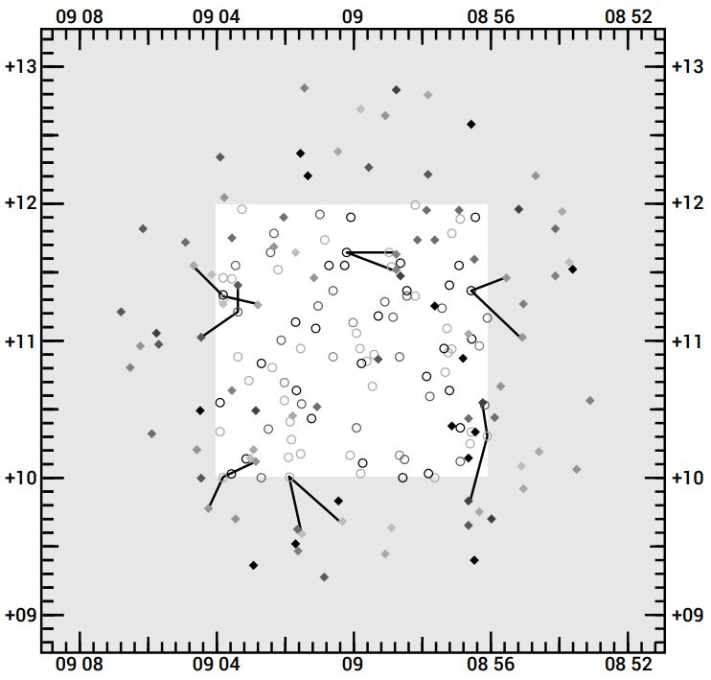Figure 1. Detected families in a 4 square degree area centred at 09h00m00s+11d00m00s. The open circles are galaxies, the filled diamonds are quasars, with lines connecting each galaxy to its detected quasar family members. The object shades indicate stepped redshift increase from light to dark over the redshift range 0.0 ≤ z ≤ 5.5. The central unshaded area shows the galaxies under examination, and the entire area shows the candidate companion quasars
This means that to a very high probability, much higher than a random association, certain quasars are physically associated with lower redshift galaxies. The quasars are found in pairs or higher multiples of two. The results further imply that these quasar redshifts indicate a real ejection velocity component and a large intrinsic non-velocity or non-cosmological redshift component.
The results described in this new paper¹ conclude that:
“… similarly, certain SDSS quasars are physically associated with lower redshift SDSS galaxies and separately with lower redshift 2MRS galaxies; at least some quasars of very different redshift are physically associated with the same nearby galaxy; with the available typed galaxy data, quasar families occur with approximately equal frequency around nearby ellipticals and lenticulars versus around nearby spirals and irregulars, and quasar families occur somewhat more frequently around nearby unbarred spirals than around nearby barred spirals.
“When analyzed separately, the bright and faint quasars maintain high and comparable detection significance around both nearby and distant galaxies, suggesting that gravitational lensing is an unlikely physical explanation for the signal that we detect.
“A quasar excess exists at Karlsson redshifts around the 2dF, SDSS, and 2MRS galaxies.”
If quasars are associated with parent galaxies, which have much smaller redshifts than the associated quasars, then that changes the whole story of the alleged evolution of the universe.

Conclusion
What does all this mean for biblical creation? Number one, it is strongly critical of the big bang hypothesis that all stars and galaxies result from the early big bang universe. This describes a scenario of quasars being ejected from active parent galaxies in a hierarchical process. If quasars are associated with parent galaxies, which have much smaller redshifts than the associated quasars, then that changes the whole story of the alleged evolution of the universe. Many quasars are more local than at enormous cosmological distances. That is, their large redshifts do not indicate a measure of distance. Again, this brings the standard big bang cosmology into conflict. How do you explain this from a big bang perspective? From a biblical creation perspective it is straightforward: God created the galaxies on Day 4 of Creation Week using this hierarchical process, where quasars are ejected from the active hearts of their parents. And we are observing, now, the results of that process.

Young galaxies too old for the big bang

New galaxies defy evolutionary explanations.
by Andrew Rigg
A team of astronomers from the University of Texas announced a startling discovery this year [2004]. They had used the 4-metre Blanco Telescope in Chile to find a long string of fully formed galaxies.¹ It has sometimes been called the Francis Filament, after team member Dr Paul Francis from the Australian National University.
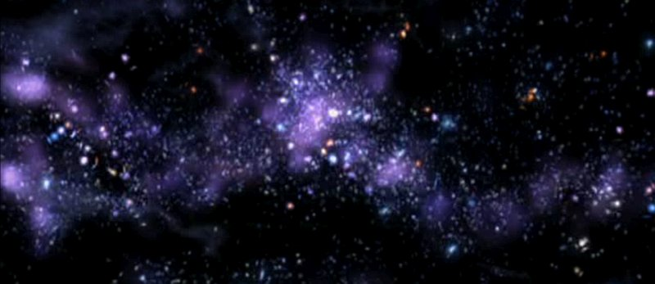
The astronomers calculated that the supercluster was 300 million light-years across, and right at the most distant edge of the universe, 10.8 billion light-years away. (A light-year is how far light would travel at its current speed of 300,000 km/s (186,000 mps) in a year—9.5 trillion km or 5.9 trillion miles.)
However, the discovery is a huge problem for evolutionary timescales. These galaxies exist when, according to big bang cosmology, they shouldn’t have had time to form.
The astronomers used a filter to block out light from other sources. This enabled them to pick out galaxies so far from Earth. They expected to find young, faint ‘proto’-galaxies spread evenly throughout the area. Instead, they found 37 mature, bright galaxies that seem to be lined up in a string, with emptiness elsewhere. It was exactly the opposite of what they expected from the big bang theory. Further observations from Siding Springs Observatory in Australia confirmed this galaxy cluster was real.
Astronomers around the world were astonished at how mature galaxies could have formed so fast in the young universe.
The galaxy cluster lies in the direction of the southern hemisphere constellation Grus (the Crane). At such a distance, evolutionary astronomers assume they are viewing the galaxies as they were around 11 billion years ago. This is allegedly just two billion years after the big bang supposedly formed the universe.
The research team caused a stir when they reported their discovery at a meeting of the American Astronomical Society on 7 January this year. Astronomers around the world were astonished at how mature galaxies could have formed so fast in the young universe.²
In the current main evolutionary model, galaxies formed from variations in the density of matter produced by the big bang. Big bangers imagine that the universe needed billions of years before stars and galaxies could form into the recognizable structures we see near the Milky Way galaxy today. But this new discovery is precisely the reverse of big-bang predictions:
- These galaxies appear to be fully formed, mature structures.
- The galaxies are aligned in a long string.
- The string is colossal—more than 300 million light-years long.
Dr Francis himself expressed the problem, ‘The simulations tell us that you cannot take the matter in the early universe and line it up in strings this large’, he said. ‘There simply hasn’t been enough time since the big bang to form structures this colossal.’
Naturalistic cosmologists will undoubtedly find a way to fit this new evidence into the atheistic big bang model. However, this would merely show that scientists always interpret facts in the light of theory. Theory, in turn, depends on one’s belief system. The big bang theory is based on naturalism—the belief system that discounts God’s recent supernatural acts to create the universe.
The existence of such large, mature galaxies lined up in a beautiful filament makes more sense when interpreted within the biblical belief system. That is, God rapidly and supernaturally created fully-formed stars and galaxies on Day 4 of Creation Week. ‘By the word of the Lord were the heavens made’ (Psalm 33:6).³

Evidence for a Young World
by Russell Humphreys
Here are a dozen natural phenomena which conflict with the evolutionary idea that the universe is billions of years old. The numbers I list below in bold print (often millions of years) are maximum possible ages set by each process, not the actual ages. The numbers in italics are the ages required by evolutionary theory for each item. The point is that the maximum possible ages are always much less than the required evolutionary ages, while the Biblical age (6,000 to 10,000 years) always fits comfortably within the maximum possible ages. Thus the following items are evidence against the evolutionary time scale and for the Biblical time scale.
Much more young-world evidence exists, but I have chosen these items for brevity and simplicity. Some of the items on this list can be reconciled with an old universe only by making a series of improbable and unproven assumptions; others can fit in only with a young universe. The list starts with distant astronomic phenomena and works its way down to Earth, ending with everyday facts.

1. Galaxies wind themselves up too fast
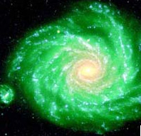Spiral galaxy NGC 1232 in the constellation of Eridanus (courtesy of the European Southern Observatory).
The stars of our own galaxy, the Milky Way, rotate about the galactic center with different speeds, the inner ones rotating faster than the outer ones. The observed rotation speeds are so fast that if our galaxy were more than a few hundred million years old, it would be a featureless disc of stars instead of its present spiral shape.¹
Yet our galaxy is supposed to be at least 10 billion years old. Evolutionists call this ‘the winding-up dilemma’, which they have known about for fifty years. They have devised many theories to try to explain it, each one failing after a brief period of popularity. The same ‘winding-up’ dilemma also applies to other galaxies.
For the last few decades the favored attempt to resolve the dilemma has been a complex theory called ‘density waves’.¹ The theory has conceptual problems, has to be arbitrarily and very finely tuned, and lately has been called into serious question by the Hubble Space Telescope’s discovery of very detailed spiral structure in the central hub of the ‘Whirlpool’ galaxy, M51.²

2. Comets disintegrate too quickly
According to evolutionary theory, comets are supposed to be the same age as the solar system, about 5 billion years. Yet each time a comet orbits close to the sun, it loses so much of its material that it could not survive much longer than about 100,000 years. Many comets have typical ages of 10,000 years.³
Evolutionists explain this discrepancy by assuming that (a) comets come from an unobserved spherical ‘Oort cloud’ well beyond the orbit of Pluto, (b) improbable gravitational interactions with infrequently passing stars often knock comets into the solar system, and (c) other improbable interactions with planets slow down the incoming comets often enough to account for the hundreds of comets observed.⁴ So far, none of these assumptions has been substantiated either by observations or realistic calculations.
Lately, there has been much talk of the ‘Kuiper Belt’, a disc of supposed comet sources lying in the plane of the solar system just outside the orbit of Pluto. Even if some bodies of ice exist in that location, they would not really solve the evolutionists’ problem, since according to evolutionary theory the Kuiper Belt would quickly become exhausted if there were no Oort cloud to supply it. [For more information, see the detailed technical article Comets and the Age of the Solar System.]

3. Not enough mud on the sea floor
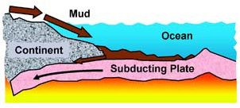
Each year, water and winds erode about 25 billion tons of dirt and rock from the continents and deposit it in the ocean.⁵ This material accumulates as loose sediment (i.e., mud) on the hard basaltic (lava-formed) rock of the ocean floor. The average depth of all the mud in the whole ocean, including the continental shelves, is less than 400 meters.⁶
The main way known to remove the mud from the ocean floor is by plate tectonic subduction. That is, sea floor slides slowly (a few cm/year) beneath the continents, taking some sediment with it. According to secular scientific literature, that process presently removes only 1 billion tons per year.⁶ As far as anyone knows, the other 24 billion tons per year simply accumulate. At that rate, erosion would deposit the present amount of sediment in less than 12 million years.
Yet according to evolutionary theory, erosion and plate subduction have been going on as long as the oceans have existed, an alleged 3 billion years. If that were so, the rates above imply that the oceans would be massively choked with mud dozens of kilometers deep. An alternative (creationist) explanation is that erosion from the waters of the Genesis flood running off the continents deposited the present amount of mud within a short time about 5000 years ago.

4. Not enough sodium in the sea
Every year, river⁷ and other sources⁹ dump over 450 million tons of sodium into the ocean. Only 27% of this sodium manages to get back out of the sea each year.^{8,9} As far as anyone knows, the remainder simply accumulates in the ocean. If the sea had no sodium to start with, it would have accumulated its present amount in less than 42 million years at today’s input and output rates.⁹ This is much less than the evolutionary age of the ocean, 3 billion years. The usual reply to this discrepancy is that past sodium inputs must have been less and outputs greater. However, calculations which are as generous as possible to evolutionary scenarios still give a maximum age of only 62 million years.⁹ Calculations¹⁰ for many other sea water elements give much younger ages for the ocean. [See also Salty seas: Evidence for a young Earth.]
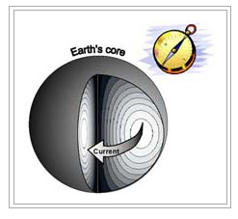

5. The Earth’s magnetic field is decaying too fast
The total energy stored in the Earth’s magnetic field has steadily decreased by a factor of 2.7 over the past 1000 years.¹¹ Evolutionary theories explaining this rapid decrease, as well as how the Earth could have maintained its magnetic field for billions of years, are very complex and inadequate.
A much better creationist theory exists. It is straightforward, based on sound physics, and explains many features of the field: its creation, rapid reversals during the Genesis flood, surface intensity decreases and increases until the time of Christ, and a steady decay since then.¹² This theory matches paleomagnetic, historic, and present data.¹³ The main result is that the field’s total energy (not surface intensity) has always decayed at least as fast as now. At that rate the field could not be more than 10,000 years old.¹⁴ [See also The Earth’s magnetic field: Evidence that the Earth is young.]

6. Many strata are too tightly bent
In many mountainous areas, strata thousands of feet thick are bent and folded into hairpin shapes. The conventional geologic time scale says these formations were deeply buried and solidified for hundreds of millions of years before they were bent. Yet the folding occurred without cracking, with radii so small that the entire formation had to be still wet and unsolidified when the bending occurred. This implies that the folding occurred less than thousands of years after deposition.¹⁵

7. Injected sandstone shortens geologic ‘ages’
Strong geologic evidence¹⁶ exists that the Cambrian Sawatch sandstone—formed an alleged 500 million years ago—of the Ute Pass fault west of Colorado Springs was still unsolidified when it was extruded up to the surface during the uplift of the Rocky Mountains, allegedly 70 million years ago. It is very unlikely that the sandstone would not solidify during the supposed 430 million years it was underground. Instead, it is likely that the two geologic events were less than hundreds of years apart, thus greatly shortening the geologic time scale.
Radiohalos (source Mark Armitage)

8. Fossil radioactivity shortens geologic ‘ages’ to a few years
Radiohalos are rings of color formed around microscopic bits of radioactive minerals in rock crystals. They are fossil evidence of radioactive decay.¹⁷ ‘Squashed’ Polonium-210 radiohalos indicate that Jurassic, Triassic, and Eocene formations in the Colorado plateau were deposited within months of one another, not hundreds of millions of years apart as required by the conventional time scale.¹⁸ ‘Orphan’ Polonium-218 radiohalos, having no evidence of their mother elements, imply either instant creation or drastic changes in radioactivity decay rates.^{19,20}

9. Helium in the wrong places
All naturally-occurring families of radioactive elements generate helium as they decay. If such decay took place for billions of years, as alleged by evolutionists, much helium should have found its way into the Earth’s atmosphere. The rate of loss of helium from the atmosphere into space is calculable and small. Taking that loss into account, the atmosphere today has only 0.05% of the amount of helium it would have accumulated in 5 billion years.²¹ This means the atmosphere is much younger than the alleged evolutionary age. A study published in the Journal of Geophysical Research shows that helium produced by radioactive decay in deep, hot rocks has not had time to escape. Though the rocks are supposed to be over one billion years old, their large helium retention suggests an age of only thousands of years.²² [See also Blowing Old-Earth Belief Away: Helium gives evidence that the Earth is young.]

10. Not enough stone age skeletons
Evolutionary anthropologists say that the stone age lasted for at least 100,000 years, during which time the world population of Neanderthal and Cro-magnon men was roughly constant, between 1 and 10 million. All that time they were burying their dead with artefacts.²³ By this scenario, they would have buried at least 4 billion bodies.²⁴ If the evolutionary time scale is correct, buried bones should be able to last for much longer than 100,000 years, so many of the supposed 4 billion stone age skeletons should still be around (and certainly the buried artefacts). Yet only a few thousand have been found. This implies that the stone age was much shorter than evolutionists think, a few hundred years in many areas.

11. Agriculture is too recent
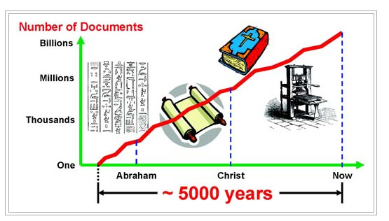
The usual evolutionary picture has men existing as hunters and gatherers for 100,000 years during the stone age before discovering agriculture less than 10,000 years ago.²³ Yet the archaeological evidence shows that stone age men were as intelligent as we are. It is very improbable that none of the 4 billion people mentioned in item 10 should discover that plants grow from seeds. It is more likely that men were without agriculture less than a few hundred years after the flood, if at all.²⁴

12. History is too short
According to evolutionists, stone age man existed for 100,000 years before beginning to make written records about 4000 to 5000 years ago. Prehistoric man built megalithic monuments, made beautiful cave paintings, and kept records of lunar phases.²⁵ Why would he wait a thousand centuries before using the same skills to record history? The Biblical time scale is much more likely.²⁴

A 5D spherically symmetric expanding universe is young
by John Hartnett
Carmelian Cosmological General Relativity theory is considered in five dimensions. For it to be consistent with both Cosmological Relativity on the largest scales and Special Relativity on the smallest scales, the acceleration of the expansion of the cosmos must have been extremely large at Creation and must be zero at the present epoch. Hence the forced stretching of the fabric of space only occurred during the Creation Week and then ceased. This implies that during the creation of the heavenly bodies, massive time dilation occurred on Earth at the centre of the expansion. It is a necessary conclusion from the 5D theory describing a spherically symmetric expanding universe that light from the most distant sources reaches Earth within the biblical time scale as measured by local atomic time, but takes billions of years as measured in cosmic time.

In physics today we have the situation where Einstein’s Special Relativity (SR) theory has been very successfully applied in the local laboratory frame with moving and stationary clocks, to GPS satellites, and in analysing the decay of cosmic particles on Earth. Einstein’s Equivalence Principle (EEP) and his General Relativity (GR) theory have also been extensively tested with space-borne clocks in rockets and satellites.
It appears that it also has been successfully applied to the large-scale structure of the cosmos—cosmology. Today, the framework of Friedmann–Lemaître–Robertson–Walker (FLRW) is used to describe the expansion of the cosmos. However, various anomalies present themselves, including the mysterious ‘dark’ matter and ‘dark’ energy, which are said to comprise about 22% and 74% of the current universe, respectively. But they are still unknown. Moreover we are told that the universe underwent a rapid expansion, and this is the reason the Cosmic Microwave Background (CMB) is so smooth and why we don’t find monopoles. There are also many other problems¹ with what has now become the standard paradigm—the big bang origin and evolution of the universe. It all seems to be unravelling at the seams.^{2,3}
In recent years, a new five-dimensional cosmology has begun to challenge the standard model—Cosmological Special Relativity (CSR) and Cosmological General Relativity (CGR), developed by Moshe Carmeli.^{4–9} However, it might well be asked whether the application of GR to the universe as a whole is correct. The underlying principle upon which the standard model is built is the Copernican or cosmological principle, which essentially says that the physics we see here is the same for the whole universe at all epochs of time. It also says that wherever the observer is, he will see essentially the same picture of the distribution of galaxies in the universe. But if that principle is wrong, then the model that results is invalid. This seems to be the state of what is nowadays called ‘consensus cosmology’.
In this paper I explore an extension of Carmelian cosmology. In itself, it has had success in describing the large-scale structure as seen in the type 1a supernovae distance modulus versus redshift data,^{10,11} and in fitting to the anomalous rotation curves of spiral galaxies.¹² I propose that the only 5D spacetimevelocity metric that can be correct on both the local scale, reproducing the 4D spacetime metric of SR and GR, and on the cosmological scale, reproducing the 4D spacevelocity metric of CSR and CGR, is one that requires that enormous cosmological acceleration and accompanying time dilation has occurred, in the past, between Earth clocks and those in the rest of the universe. This means the universe is very young as measured by Earth clocks. It only has the appearance of great age because we are biased by the vast size of the universe. Based on the observed retardation of cosmological clocks in the distant universe, I postulate that during Creation Week, specifically on Day 4, Earth clocks ran extremely slowly compared to the rest of the universe.
This means that if the new theory is shown to fit the observations of the large-scale structure of the universe and is consistent with Einstein’s well-tested special relativity theory, then we are forced to conclude that the correct understanding of the expanding universe means that clocks on Earth once ran at much slower rates than clocks in the universe. As a result, we have a mechanism for light to travel to Earth from the most distant galaxies within the biblical timescale.

Cosmological Relativity
The new 5D cosmology contains all of standard GR as a subset. All of the results in GR that are experimentally supported are also obtained in CGR.⁸ On the local scale where the universe is not expanding, Cosmological Relativity has no application. CSR applies a structure, similar to SR, to the whole cosmos without taking matter into account. When matter is added, CGR is required.
Here the CGR theory is considered using a Riemannian five-dimensional presentation of gravitation in which the coordinates are those of Hubble (i.e. proper distances as measured by the Hubble law and the measured redshifts of galaxies), and atomic time as measured by Earth clocks.
The metric^{4,7} used by Carmeli, in a covariant theory, extends the number of dimensions of the universe by the addition of a new dimension—the radial velocity of the galaxies in the Hubble flow. The Hubble law is assumed as a fundamental axiom for the universe and the galaxies are distributed accordingly.

5D line element
Initially, let us confine the discussion to an expanding universe without matter. The line element^{5,6} is that of CSR and is given by
where τ is the Hubble-Carmeli time constant, the reciprocal of the Hubble parameter H₀ in the limit of weak gravity, and it is a constant in this epoch of time. The coordinate v is the expansion velocity of the cosmos, the radial speed of the expanding fabric of space. Coordinates x, y and z are spatial coordinates, and t is atomic time as recorded by Earth-based clocks. When ds = 0 one gets the Hubble expansion with no gravity, but this also requires dt = 0.

γ-factor in SR
Writing dr² = dx² + dy² + dz² in arbitrary spatial co-ordinates, (1) becomes
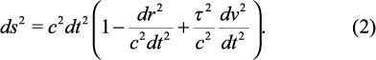
Now dividing by ds² ,
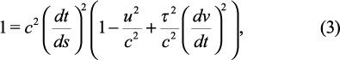
where u = dr/dt. Therefore the relativistic γ-factor (γ_{E}) is
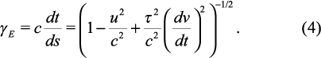
And when dv/dt → 0,
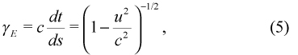
as per Einstein’s SR. This is because SR does not deal with an expanding space; that is, v is identically zero. The result is the usual γ-factor in SR, which causes strange relativistic effects (time dilation and length contraction) at high relative speeds; that is, where u → c. Besides on the local scale, the universe is not expanding now.

γ-factor in CSR
Similarly, from (1) it follows that
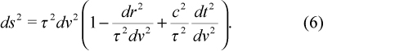
Dividing by ds² ,
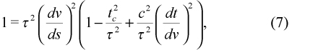
where t_{c} = dr/dv is cosmic time measured backwards from t_{c} = 0 at the observer, but determined from the expansion. By contrast, t is the locally measured atomic time. Therefore the relativistic γ-factor (γ_{C} ) is
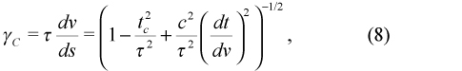
When dv/dt is large compared to a₀ = c/τ
as per Carmeli’s CSR.⁷ This is the normal case in the cosmos in CSR. The motion of the galaxies is dominated by the expansion, and local motions are negligibly small. As t_{c} → τ, this γ-factor causes velocity dilation and length contraction analogous to that in SR.

Lorentz transformations
Since we assume Hubble law to be axiomatically true, v ≈ H₀ r. Therefore locally,
Hence it follows that dv/dt → 0 as dr/dt → 0. We know that local space is not expanding. Therefore it follows from (2) that we can set dv/dt → 0 in (4) resulting in (5), and hence space and time coordinates transform according to the usual Lorentz transformations in SR.
In cosmology, space and velocity coordinates transform by the cosmological transformation,¹³
Comparing the above transformations shows that the cosmological transformation can be formally obtained from the Lorentz transformation by changing t to v and c to τ (hence u/c → t_{c} /τ). Thus the transfer from ordinary physics to the expanding universe, under the above assumption of empty space, for null four-vectors is simply achieved by replacing u/c by t_{c} /τ, where t_{c} is the cosmic time measured with respect to us now.

Time dilation
Let us now suppose that the observer is located at the centre of the expansion. Let us also represent the time interval recorded by an inertial clock, co-moving with expanding sources¹⁴ attached to space as dT and local Earth-based atomic time interval as dt. From (2) we can write
Let us assume that motion through space is negligible. Therefore with u → 0,
At the present epoch dv/dt = 0 because we observe no expansion. This means, except for curvature effects, which are presently ignored, clocks in the universe run essentially at the same rate as on Earth. However, if dv/dt was much greater than c/τ = a₀, a universal constant, it follows that dt << dT. I propose that this was the case during Day 4 of Creation Week and vast amounts of time passed on the galaxies expanding out from the centre of the universe with little time passing at the centre.
This is the critical point in understanding this paper. The assumption is that during the creation of the heavenly bodies¹⁵ on Day 4 the universe underwent a very rapid expansion. For example, the Bible tells us:
‘He wraps himself in light as with a garment; he stretches out the heavens like a tent’ (Psalms 104:2).
‘He sits enthroned above the circle of the earth, and its people are like grasshoppers. He stretches out the heavens like a canopy, and spreads them out like a tent to live in’ (Isaiah 40:22).
‘This is what God the Lord says—he who created the heavens and stretched them out, who spread out the earth and all that comes out of it, who gives breath to its people, and life to those who walk on it’ (Isaiah 42:5).
‘This is what the Lord says—your Redeemer, who formed you in the womb: I am the Lord, who has made all things, who alone stretched out the heavens’ (Isaiah 44:24).
The very fabric of space was stretched, and during that time of stretching, stars and galaxies were created.¹⁶ In order to conserve energy (and because of the underlying conservation laws imposed by the Creator) the period also involved massive particle production. This conclusion naturally results from the same 5D theory.¹⁷ This involved the creation of the stars and galaxies via massive ejection events from the centres of active galaxies and quasars. Though still controversial, this idea has observational support. Halton Arp and other astrophysicists have published many papers and a few books¹⁸ supporting this hypothesis based on decades of observations. Their view is totally naturalistic, whereas in the creationary model presented here all matter created this way was created during Day 4. This was part of the creation of the heavenly bodies, which we are able to see and which reveals His Glory for all to see.¹⁹
Now considering the fact that this would mean when we look out into the cosmos we are looking back in time, due to the finite speed of light, we are then looking at the events of Day 4 creation as they are actually happening. This also implies that the expansion of the universe only occurred during the Creation period, over six thousand years ago as measured by Earth clocks. The universe may no longer be expanding; at least the expansion is no longer accelerating. But we are seeing the after-effects of that expansion.
Therefore we expect that the environs of the solar system are not affected by any expansion now, which is consistent with the Hubble law, i.e. no expansion locally. But outside the Milky Way residual effects are still observed, particularly towards the limit of observation. And it is at great distances and towards the limits of the visible universe where the CGR theory is most applicable. But since we are looking back in time the great distant events actually occurred during the Creation Week. A large value of dv/dt, meaning dt/dv << a₀ (c.f. eq. (8)), is consistent with the basis of CGR, which has been successfully applied to the high redshift (very distant) observations of the cosmos.¹⁰
The question might be asked, ‘Shouldn’t we then see massive blueshifts because of the existence of the large time dilation between sources at the edge of the universe and those at the observer?’ No, the time dilation that (14) refers to only occurred on Earth during the period of rapid expansion. Once the expansion was switched off there would be no difference in clock rates.²⁰ And the expansion was switched off six thousand years ago. The Creator, who is omnipresent, switched off the acceleration when he stopped stretching out the fabric of space at that time. If we were on Earth to observe the cosmos during the period when the acceleration stopped we may have seen blueshifted starlight change colour as Earth clocks began to tick at approximately the same rate as cosmic clocks.
What we now observe in the universe is the redshifted light from the galaxies that has resulted from the expansion, not from this time dilation mechanism. The light is continuing to travel towards the Earth from the distant galaxies, as it has for billions of years by cosmological clocks, but because Earth clocks now run at the same rate we only observe expansion effects. The reference clocks in the cosmos are these cosmological or Hubble clocks, which can be related to redshift z by⁹
As z → ∞ we are seeing back towards the beginning of time, where t_{c} → τ ≈ 13 billion years. But because this observation does not take into account the episode of rapid (superluminal) expansion (which is not observable today) the universal constant τ more correctly describes the size of the universe, not its true age as measured by Earth clocks.

One-way speed of light
We can write (1) as
where dr² = dx² + dy² + dz². Dividing (16) by dt², and equating ds = 0 for the trajectory of a photon in spacetimevelocity, we get
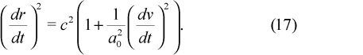
The speed of light, c, in (17) is actually the locally measured two-way speed. The speed dr/dt is not the measurable two-way speed of light c but the non-measurable one-way speed of light.^{21,22} It tells us the speed of the expansion with respect to local Earth-based atomic clocks. Notice if dv/dt is zero we get the usual limiting speed c of SR. However, if dv/dt was extremely large in the unobservable past in the vicinity of Earth, as it now appears to be in the cosmos, which is in our past, then the one-way speed of light also was much larger then.
The apparent effect on the one-way speed of light dr/dt is really the direct result of time dilation. The actual measurable speed of light has not changed. It is time that is the variable in these equations, and as a result only appears to be producing enormous theoretical changes in the one-way speed of light, as seen by the observer. The actual speed of light is always the two-way speed c and is constant.

Spherically symmetric universe
From (16) it may be noted that this result is true in general for any coordinate system. In the real universe I consider the case of spherically symmetric coordinates, but it should be remembered that the time dilation is not the result of the choice of a coordinate frame.
In a spherically symmetric, isotropic, expanding²³ universe, evenly filled with matter of density Ω_{m}, it can be shown that for a photon trajectory:
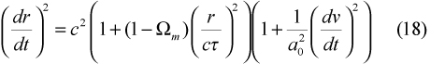
where the effects of adding matter have been included in (17). Here Ω_{m} is the averaged matter density of the universe expressed as a fraction of the critical density, which in this theory is 3/8πGτ² ≈ 10^{–29} g/cm³ . The additional term results from solving Carmelian 4D spacevelocity representation of the large scale structure of the universe.
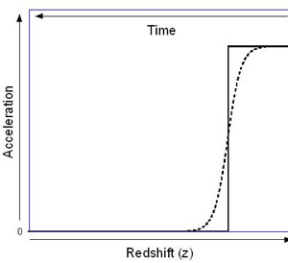Figure 1. Acceleration defined by (20) is plotted against redshift or time. Redshift is indicated and increasing towards the right and time from the Creation as increasing towards the left. The scales of the axes are arbitrary except for the origin. The solid curve indicates at some time during Creation the acceleration was switched from an extremely large number to zero. The broken exponential curve indicates that this may have occurred very rapidly but not instantaneously. In order to model this in (20)–(23) the exponential curve was chosen.
At the current epoch anywhere in the universe (17) holds. That means that the local physics is determined solely by SR, as expected, because dv/dt measured against local clocks is zero. However at past epochs dv/dt is non-zero and CSR must be applied instead. When matter is added, on a sufficiently large enough scale, the situation changes and we use (18). This means (18) is only really valid in a neighbourhood of a universe that is spherically symmetric around the origin—hence it must involve an isotropic matter distribution. Homogeneity is not required.

Light travel time
In order to calculate the light travel time in the universe from light sources at the edge we need to know the speed of the photons in terms of atomic time as measured by Earth clocks which have undergone a period of massive time dilation during the first days of Creation, especially on Day 4 when the Creator created the heavenly bodies. This is not the speed of light in terms of cosmic time, which is always c, and since Earth clocks now tick with nearly the same rate as cosmic clocks c is the locally measured value now also. So we need to know dr/dt where r is the proper distance to the source and t is atomic time units on Earth.
We have observed in (8) that the value of dv/dt needs to be very large at high redshifts (z >> 0) at cosmic times t_{c} >> 0, but from (4) it is clear dv/dt needs to be zero at the current epoch t_{c} = 0 (z ≈ 0). This is best described by a step function,
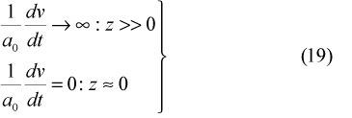
as shown in the solid curve in figure 1. The function (19) is shown with a finite maximum value, which at this stage we can only say was extremely large. This means that at the Creation the acceleration dv/dt was very large and then at some value of redshift z ≈ 0 the acceleration was switched to, or rapidly decreased to, zero. This switching was physically associated with the stretching of the fabric of space itself, as God spread out the heavens.
Now the function (19) can be approximated by an exponential of the form
where η is a dimensionless proportionality constant that is yet to be determined. The function in (20) has the needed characteristics and can be related to redshift z, using (15). This function is also illustrated by the broken curve in figure 1 where a maximum value has been imposed. However, for the purpose of the following calculations, (20) is used instead, which increases without bound as t_{c} → τ or as z → ∞.
From a comparison of the magnitudes of the terms in (18) the matter density term can be neglected for the purposes of calculating the light travel time in the universe in terms of Earth atomic time units. It follows from (18) with Ω_{m} = 1 and (20) that
is the one-way speed of light; the speed light travels toward the observer at the origin of a spherically symmetric universe, determined from the proper distances which the photons travel but with respect to local Earth-based atomic clocks. Note that (17) does not depend on spherical matter symmetry, but it only applies to an empty universe.
Into (21) we can substitute t_{c} /τ → v/c, where v is the expansion speed. Now I make the assumption that the Hubble law (v ≈ r/τ) also applied at the Creation. Therefore it follows that
By integrating (22) we can calculate the distance light travelled in atomic time t:
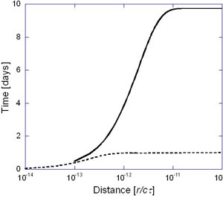Figure 2. The light travel time (in Earth days) is plotted against distance in the universe (in units of cτ) for two choices of the dimensionless free parameter η = 10¹² (solid curve) and 10¹³ (broken curve). Both curves become flat, meaning that the light travels the rest of the distance to the limits of the universe in the time shown.
With c = 1 light-year/year and the chosen value of τ = 13.6 billion years¹¹ the distance scale cτ = 13.6 billion light-years. Now the light travel time has been calculated from (23) using η = 10¹² and 10¹³ , and is shown in figure 2. For large γ in (23) the light travel time t approaches a maximum value of 2τ/η. The result is an exponentially rising function that means light fills the universe to vast distances within 1 day (by Earth-based clocks) assuming the value of η = 10¹³. Depending on the exact magnitude of the undetermined parameter the light travel time may be days or, at most, years as measured by Earth based clocks.
Estimates for the size and extent of the acceleration term dv/dt may vary. At the present epoch in our local vicinity it is identically zero because the environment of the solar system is designed for life. In the past it was enormously larger as evidenced by the cosmos. Reducing the value of η in (23) will increase the length of time for light to traverse space in our time units, but this theory solves what has seemed to be a difficult problem.

Conclusion
Within the framework of Carmelian cosmology, for the 5D theory to be consistent on all scales (i.e. consistent with both SR on the local scale and CGR on the largest scales), the acceleration of the fabric of the expanding universe must be extremely large at high redshift and zero in the solar system. This then leads to the conclusion that at the Creation massive time dilation occurred with respect to the observer at the centre of a spherically symmetric, expanding universe. It also means that what we would calculate the one-way speed of light (not the actual speed of light that determines the physics in any local environment) is extremely large at high redshift—a direct result of massive time dilation and not any change in the speed of light. Therefore, light from the most distant galaxies could traverse the distances in a matter of a few days as measured by Earth-based atomic clocks, depending on the details of the magnitude of the past acceleration.
This then leads to the conclusion that at the Creation massive time dilation occurred with respect to the observer at the centre of a spherically symmetric, expanding universe.
And there are no anomalous results on the aberration of starlight or any other well-proven relativistic effects because the speed of light measured locally with atomic clocks is always the constant c. Light arriving at Earth is stretched by expansion (hence redshifts observed) but because Earth based clocks at the present epoch run nearly at the same rate as cosmic clocks no other effects are observed.
The time dilation effect occurred on Earth during the Creation Week and was switched off simultaneously with the cessation of the acceleration of the expansion. This means the universe may no longer be expanding; we only see residual effects because of the finite travel time of light. An observer on Earth during the epoch of expansion would have seen large blueshifts. Currently, only redshifts are observed on the large scale in the universe. Everywhere within six thousand light years of Earth the expansion can be observed to have ceased, and this sphere of observation expands as the light continues to arrive from farther and farther away. Therefore, events farther out are coming from Creation Week.
Observations are consistent our galaxy being situated at the centre of a 5D spherically symmetric universe of finite extent that has expanded many-fold. In terms of cosmological clocks it is as if the universe appears like a still photograph. This is the result of the vast distances and slow intrinsic motions on the cosmological scale. Nevertheless, the validity of the new theory applying to both the current and past epochs leads to the inescapable conclusion that the time it has taken light to travel from the most distant sources to Earth is billions of years of cosmic time, yet a matter of only days or years in local atomic time units.

Why young-age creationism is good for science
by Brett W. Smith
The current treatment of young-age creationists in the scientific community and society at large is unfair and unwise. Scientists and philosophers of science, including old-age creationists and naturalists, should respect young-age creationists as legitimate contributors to science. Young-age creationists offer to the current origins science establishment a competing rational viewpoint that will augment fruitful scientific investigation through increased accountability for scientists, introduction of original hypotheses and general epistemic improvement.

Photo by John WhitmoreFigure 1. Fossil footprints in the Coconino Sandstone, Arizona. These are tracks similar to those studied by Leonard Brand and are found at many locations throughout northern Arizona.
It is no secret; young-age creationists (hereafter YACs) have a poor reputation in the scientific community at large. Those working from a biblical young-age perspective receive criticism not only from naturalists but also from progressive creationists who hold the earth to be billions of years old. It may be worth asking why most scientists criticize young-age creationists, but such is not the goal of this article. The goal is rather to state positively why all scientists and philosophers of science—from misotheist Daniel Dennett to Intelligent Design theorist William Dembski—should see young-age creationism (hereafter YAC) as a good thing for science.
The basic idea is that YACs offer to the current origins science establishment a competing rational viewpoint that will augment fruitful scientific investigation through increased accountability for scientists, introduction of original hypotheses, and general epistemic improvement. Before this argument can leave the ground for many readers, however, a few preliminary comments are in order.
Some may wish to quibble over the definition of science. One may insist that science proceed only upon testable hypotheses, ruling out any ‘religious’ view from the beginning. I would not be the first to point out that, if no untestable hypotheses are allowed, evolutionary biology and uniformitarian geology are not true sciences either. A more sensible approach would be to make a distinction between science that does restrict itself mostly to testable hypotheses and science that, by necessity, involves some scarcely testable or untestable hypotheses. Some have called the former ‘empirical science’ and the latter ‘historical science’.¹ A more useful term for the latter may be ‘speculative science’, since some philosophical scientific theories, like string theory, are ultimately untestable yet unrelated to direct questions of history. Still, all of the ‘historical’ sciences fall in the category of speculative science. No science that postulates an origin for the universe, the earth, or the human race has any hope of ridding itself of untestable and significant hypotheses, such as ‘God did (or did not) enact direct causation on the universe in the past.’ Further, it would stretch the definition of theology or religion too far to insist that YACs are conducting theological or religious experiments when they place fish in a tank and watch them rot to learn about how to interpret fish fossils, for example.² Such science is still science more than it is anything else; it is simply speculative science.
The young-age creationist does nothing fundamentally different in science than the naturalist, however objective and detached the naturalist may seem. Everyone processes experience with a set of preconceived notions. Call them control beliefs, presuppositions, operating assumptions, basic beliefs or a worldview; it matters not. Even the ideally objective scientist, supposing there is such a thing, makes the wild assumption that objectivity is the path to knowledge. What if God created the world and the human race in such a way that rightly directed passions are necessary for an accurate understanding of natural phenomena? That is to say, what if those who love God are the only ones who can really see the world clearly? The truly objective (and therefore passionless) scientist could miss an accurate representation of the world completely. Surely maintaining the (very recent) scientific tradition is not worth such a risk! At any rate, the presumption of naturalism is no more warranted than the presumption of theism, as many have argued.³ All scientists use empirical data to explain the world as they understand it; some just begin with a different understanding of the world. If there is any methodological difference between creationist scientists and naturalistic scientists, it is that creationists must (due to social pressure) acknowledge and critically reflect upon their assumptions where they meet scientific inquiry, while naturalists always face the temptation of uncritically hiding behind naturalistic methodology. If anyone has a special claim to being a responsible scientist, it is probably the creationist.
Some may insist on a distinction between speculative-but-naturalistic science and speculative-and-religious science. Such a distinction is arbitrary because naturalism involves serious metaphysical assumptions and has serious ethical implications like any other religion.⁴ Nevertheless, definition of the word ‘religion’ is beside the point. The real problem with ruling YAC out of science on religious grounds is the educational oppression such a distinction is causing. In the United States, religion cannot be forced dogmatically upon students in public schools, but ‘science’ can. Questions relating to the origin of the world and the human race are far too important for any answers on any grounds using any definitions of ‘religion’ and ‘science’ to be passed off as public knowledge without dissenting voices being heard—so long as their arguments are rational.

The adversarial system
YAC has the potential to improve the world of science significantly through increased accountability for speculative naturalistic scientists.
Whatever one chooses to call it—a science, a pseudoscience, or a religion—YAC has the potential to improve the world of science significantly through increased accountability for speculative naturalistic scientists. The US legal system is a good example for how science should, and could, work. US criminal trials operate on the adversarial system, in which two lawyers face off, one unequivocally in defense of the defendant, and one unequivocally prosecuting the defendant. If any lawyer seems to lose a case on purpose, even if it is because the plaintiff decided that the defendant really was innocent, that lawyer can lose his or her license. This system, though it is often abused, is actually ideal for ensuring justice in the majority of cases. As long as one lawyer is not vastly superior to the other, each lawyer will offset the arguments and even the theatrics of the other, and the jury, considering both one-sided arguments together, will see the truth. The actual guilt or innocence of the defendant is irrelevant to the task of the lawyers, yet their faithfulness to their assigned tasks is what helps ensure that the truth comes to the surface. If there is any doubt regarding the superiority of the adversarial system, one need only reflect upon the gross injustice of other systems, where much relevant evidence and very good arguments never find their way to the courtroom because no lawyer is assigned to bring them.
Arthur Miller’s depiction of the Salem Witch Trials in The Crucible illustrates the injustice of trials held without a functioning adversarial system.⁵ Historical accuracy and his actual motivation for writing aside, Miller’s story teaches an important lesson. In the play, the townspeople of Salem end up accusing and executing several ‘witches’ whose only crime was that their accusers did not like them, wanted their land, or had some similar unjust reason to get rid of them. The eyewitness accusers carry the day because no one really considers the arguments which the ‘witches’ offer in their own defense. The Crucible reminds us that innocent people can lose their lives when the adversarial system breaks down and the accused have no voice with which to make a defense.
YACs are the ‘witches’ of contemporary science, and scientific scholarship is proceeding roughly like Miller’s version of the Salem Witch Trials. YAC has not received a fair hearing in actual scientific scholarship. Those who believe the earth to be young often have to hide or understate their beliefs for fear of the dreaded (and false) accusation that they are perverting science with their religious beliefs—a crime punishable by scholarly death. The brave few who articulate their view honestly and candidly suffer a fate like Giles Corey, the character in The Crucible who is slowly crushed to death as he obstinately refuses to confess his alleged connection to witchcraft.⁶
If scientists learn the advantage of the adversarial system for science, YACs will turn from witches to attorneys, and all will benefit. Suppose, for the sake of argument, that the theory of evolution is true and that the earth really is billions of years old. Is there any benefit in maintaining a naturalistic dogma in scientific methodology? If the naturalist is correct, what has he to fear from a minority group that wishes to approach his data from a different perspective? He, with society, only stands to gain. As he and his adversaries all present the best case that they can make, they can offset one another’s erroneous biases, and the truth can show through all the more clearly. For this very reason every rational view ought to have some staunch defenders. If a rational view gets dismissed from scientific discourse without vigorous defense, the public has as much reason to trust the court rulings of Miller’s Puritans as to trust a naturalistic interpretation of scientific data.

Multiple working hypotheses
T.C. Chamberlin introduced an embryonic version of the adversarial vision for science in 1890 with a paper entitled, ‘The Method of Multiple Working Hypotheses’.⁷ Chamberlin suggested that each individual scientist, rather than defending only a pet theory, ought to consider multiple rational hypotheses based upon radically different conceptual schemes when approaching each problem in science. That way, he would not fall prey to bias and, more to the point, his multiple hypotheses considered together would be much more likely to encompass the incurably complex truth than would any one pet theory. He wished to apply his method to Darwinian evolution directly:
‘As an illustration, it is only necessary to cite the phenomenal influence which the Darwinian hypothesis has exerted upon the investigation of the past two decades. But a single working hypothesis may lead investigation along a given line to the neglect of others equally important; and thus, while inquiry is promoted in certain quarters, the investigation lacks in completeness. But if all rational hypotheses relating to a subject are worked co-equally, thoroughness is the presumptive result, in the very nature of the case.’⁸
Perhaps origins science would have progressed much more efficiently in the past century if Darwinists had heeded Chamberlin’s advice.
The only problem with Chamberlin’s view is his characteristic modernist optimism that an individual scientist actually could give adequate consideration to all rational hypotheses in any given situation. Inevitably, most rational hypotheses would not enjoy the thorough consideration that an advocate dedicated to each individual view could provide. The adversarial system offers a great improvement upon Chamberlin’s view because it ensures that all rational hypotheses will get a fair chance at explaining the data as long as scientists with different hypotheses take one another seriously. Science would not then depend upon hapless individual attempts at pure, passionless objectivity. Rather, the collective efforts of unashamedly biased—that is, honest—scientists would create a collective objectivity in scientific investigation.

Scientific revolutions
Only when scientists are allowed to dive whole-heartedly into defense of the theories they hold dear, provided they maintain intellectual integrity, can society really be confident that all rational hypotheses have been weighed on just scales.
There is a significant disanalogy, however, between a legal adversarial system and the scientific adversarial system in which YAC should be allowed to play a part. In the legal version, fundamental biases for or against the defendant are assigned or hired. In the scientific version, each scientist chooses (or at any rate uses) whichever research-guiding biases seem best to him or her. In this way, the scientific adversarial system actually has a better prospect of success than the legal system. Even the most honest and dedicated lawyer is not likely to put forth effort equal to one contending for the basic hypotheses that shape his view of the world. Only when scientists are allowed to dive whole-heartedly into defense of the theories they hold dear, provided they maintain intellectual integrity, can society really be confident that all rational hypotheses have been weighed on just scales.
Thomas Kuhn, reflecting upon the history of science, comes to a surprisingly similar conclusion in The Structure of Scientific Revolutions.⁹ Kuhn sees scientific history as a series of revolutions in which a dominant paradigm for science is gradually supplanted by another that then becomes dominant. As one paradigm, or scientific methodological worldview, is nearing its demise, however, there are always some who hold tenaciously to the old paradigm as long as they can. They have faith that their paradigm will ultimately prove to be right. Kuhn writes about such faith:
‘Inevitably, at times of revolution, that assurance seems stubborn and pigheaded as indeed it sometimes becomes. But it is also something more. That same assurance is what makes normal or puzzle-solving science possible. And it is only through normal science that the professional community of scientists succeeds, first, in exploiting the potential scope and precision of the older paradigm and, then, in isolating the difficulty through the study of which a new paradigm may emerge.’¹⁰
The key phrase in this passage is ‘exploiting the potential scope and precision of the older paradigm.’ Although Kuhn does not advocate an adversarial system for science, he recognizes that dedication to one’s paradigmatic hypotheses about science is the key to discovering, for the scientific community in general, just how far a theory can go in explaining the data. In the current discussion, naturalists serve to show evolution’s best explanation of scientific data (its ‘scope and precision’) and YACs serve to show how well the biblical creation account can explain the scientific data. Kuhn does not think that two paradigms can coexist for long, but that is where the current scientific community needs to prove him wrong. Kuhn sees the largely socially-driven succession of one totally dominant paradigm after another as evidence that science does not yield truth but rather proceeds toward no particular goal.¹¹ If multiple paradigms can remain in dialogue for an extended period of time, scientists will have the opportunity to show that creationists and naturalists are not talking past one another and that they have enough common ground to suggest very strongly that there must be a real truth in science toward which both are moving. Otherwise, their intelligent debate based from radically different paradigms would be nearly inexplicable.

Examples of YAC adversarial science
To a notable extent, YACs are already doing their part for adversarial science in a role that even the Intelligent Design movement cannot fill. YACs are showing, through real, responsible research that they have some valuable, original hypotheses to suggest based upon a biblical young-age model. Some YACs, such as Leonard Brand, Russell Humphreys, and Steve Austin have made scientific discoveries that were long overlooked by naturalists because the young-agers dared to suggest hypotheses which would never have occurred to one dedicated to an old-age view.
The Coconino Sandstone
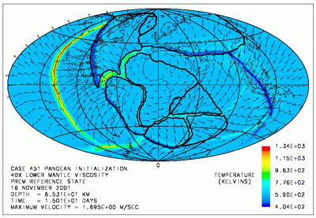An image of the continental plates generated by Dr Baumgardner’s Catastrophic Plate Tectonics model.
Paleontologist Leonard Brand has made a significant contribution to the study of the Coconino Sandstone, a layer of fine-grained sandstone that sprawls over much of northern Arizona.¹² At least since 1933, the standard interpretation of the Coconino Sandstone has been that it formed from wind-blown sand dunes in a desert climate.¹³ The many fossilized vertebrate footprints in the lower half of the deposit had been interpreted as having been made on dry sand, even though, before Brand, no one had conducted rigorous laboratory experiments to determine whether the prints really looked more like underwater prints or prints made in dry sand. The wind-deposited model seemed satisfactory to old-earth geologists, so it is unlikely that anyone would have sought to reinterpret the fossil footprints any time soon. However, because his biblical Flood model for geology implies that the Coconino Sandstone was more likely laid down underwater, Brand set out to discover whether the fossil footprints really fit the Flood model or a desert deposit model better. Figure 1 shows an example of the kind of footprints Brand studied.
Brand published articles in major geology periodicals in 1979 and in 1991. In the first experiment, published in Palaeogeography, Palaeoclimatology, and Palaeoecology, Brand set up meticulous lab simulations of underwater, partially underwater, slightly moistened, and dry sand environments and observed the footprints made by a variety of reptiles and amphibians in those differing environments.¹⁴ After carefully comparing the experimental footprints with the fossilized footprints, Brand found that the tracks made underwater were the best match for those recorded in the fossil record.¹⁵
In the course of Brand’s original study, he noticed that nearly all of the Coconino vertebrate tracks were going uphill and that the tracks that did cross the slopes laterally still had the toes pointed up the slope. Brand suggested that the best explanation for these phenomena was that there was a slight underwater current when the creatures left the prints. In conjunction with Thu Tang, Brand later put his hypothesis to the test and published his results Geology in 1991.¹⁶ Brand and Tang studied many more Coconino trackway collections and observed the underwater track-making of western newts, video-taping the activity of the newts in tanks with flat sand and a current of 8 cm/second and examining the tapes frame-by-frame.¹⁷ In lockstep with Brand’s hypothesis, the current often pushed the experimental newts sideways, causing them to leave tracks that look like the tracks in the sandstone that inspired Brand’s low-current hypothesis. Also, Brand and Tang found that many of the trackways in the Coconino have unexpected gaps in them with no evidence to suggest that the missing tracks have been erased. Brand’s underwater current explanation potentially solves that mystery because the gaps could have been caused by the creature getting picked up by the current and set back down in another place.¹⁸
Several mainstream geologists have recognized the value of Brand’s young-age hypotheses. Both of the published papers on his original experiment are cited in Beus and Morales’ Grand Canyon Geology Second Edition, in which volume Middleton, Elliot and Morales acknowledge the legitimacy of Brand’s work and suggest that further experimentation is needed to settle the origin of the Coconino Sandstone.¹⁹
Even Brand’s critics have praised his work as legitimate and fruitful science. Martin G. Lockley of the University of Colorado disagreed strongly with the conclusions of Brand and Tang’s 1991 work. Such disagreement is to be expected on the adversarial model of science. Despite his differing opinion, Lockley acknowledged that Brand and Tang had made a helpful contribution to the field, saying, ‘ … Brand and Tang are to be congratulated for a thorough experimental study, which presents more Coconino track data than have appeared at any time since the inaugural studies of Gilmore.’²⁰
David B. Loope of the University of Nebraska acknowledged Brand’s positive contribution to historical geology even as he voiced his disagreement with Brand’s conclusions. He wrote,
‘Brand and Tang (1991) have brought some very puzzling aspects of these spectacular trace fossils to the attention of a broad audience … Although I strongly disagree with Brand and Tang’s conclusion, I find their experimental approach very useful, and hope to incorporate it in the testing of my own hypothesis.’²¹
Nuclear decay in zircons
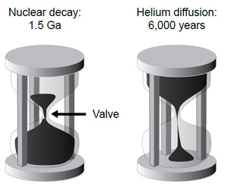Two hourglasses representing the same rock. In the first, 1.5 Ga worth of radiometric decay at today’s rates has occurred, while in the second, only 6,000 years of helium diffusion has taken place.
D. Russell Humphreys’ work with nuclear decay in zircons is another shining example of YAC having positive and helpful input for science, precisely because of young-age presuppositions informing a scientist’s hypotheses. Radiometric dating is obviously a huge problem for YACs like Humphreys, who holds the earth to be about 6,000 years old.²² However, YACs have come up with a significant challenge to the assumption that radioactive decay has occurred at the same rate throughout earth history. Based upon biblical indications of a young universe, YACs have hypothesized that abnormally rapid radioactive decay occurred during the Flood. Humphreys put this hypothesis to the test by boldly predicting and publishing theoretical Helium ‘leakage’ rates from zircon crystals based on old-earth and young-earth models.²³ Humphreys sent samples of the zircons in question to an independent lab for testing, and the test results were consistent with Humphreys’ young-earth prediction.²⁴ More to the point, a second set of data confirmed the first set and directly repudiated the 1.5-billion-year age geologists had measured for those zircons based upon the amounts of uranium, thorium and lead in the crystals. If the zircons were really as old as the traditional and trusted radiometric dating method indicated, the Helium decay rates should have been around 1/100,000 of what the tests showed them to be.²⁵ Before Humphreys, it had not occurred to any uniformitarian geologist to test the diffusion rates of helium in zircons, but the tests are proving very relevant. Humphreys, like Brand, has suggested a new and fruitful line of research because of his young-age beliefs, and he has shown the former interpretation of radiometric data to be in need of further investigation.
Mount St Helens
Steve Austin, who holds a Ph.D. in Geology from Pennsylvania State University, also took bold and fruitful action on the basis of his young-age beliefs. Even though K– Ar dating is supposed by uniformitarians to measure rock ages in the millions of years, he decided to test the dating method by measuring the amount of argon in rocks with a known age. He chose porphyritic dacite which hardened in 1986 on Mount St. Helens. The rocks returned ages ranging from 0.34 to 2.8 Ma.²⁶ This massive dating error revealed that the age of an igneous rock is not necessarily ‘reset’ each time the rock melts, as uniformitarians had generally assumed. In the case of Mount St Helens, some argon apparently had been trapped in the lava, making the rocks appear as though potassium had been decaying and producing argon for much longer than the rock had really existed. Austin’s work has highlighted the problem of dating such rocks, thanks to thinking inspired by his belief in biblical creation.
Other examples
Brand, Humphries and Austin are good examples of YACs who are making positive contributions to science, but many like them are doing noteworthy science from a young-age perspective. A few others include John Baumgardner, Werner Gitt, John Sanford and John Hartnett.
John Baumgardner, a Princeton University alumnus and technical staff member at Los Alamos National Laboratory, developed a computer model for the interior of the earth as a part of his effort to contend for the biblical young-age view. He based his model upon the biblical account of the Flood, supposing that a global catastrophe in the recent past can explain the current state and actions of the earth’s crust. Baumgardner’s model project has received funding from NASA and been recognized as the best computer model of its type in the world. The US News and World Report (June 16, 1997) called him ‘the world’s pre-eminent expert in the design of computer models for geophysical convection.’²⁷
German creationist Werner Gitt has done significant work in information science, including writing the book In the Beginning was Information, which presents an argument that information must have an ultimate personal source.²⁸ Dr Gitt has helped the information science community move toward a better understanding of what information really is by building upon the work of Claude E. Shannon.²⁹ His thoughtful contributions to that pioneering field could not be what they have been if not for his religious views.
In similar manner to Gitt, John Sanford’s YAC views on origins led him to contribute to the conversation in his field—genetics. Sanford argues in Genetic Entropy and the Mystery of the Genome that there has not been enough time in evolutionary history for random mutations, which are almost always detrimental to an organism, to develop an ape into a man.³⁰ With the Second Law of Thermodynamics in his favour, Sanford has a rational view that calls for defence. Of course many disagree with the conclusions of Gitt and Sanford, but the strong, reasoned arguments for and against their views are the very sorts of thing that will bring greater progress through adversarial science. A uniform group of evolutionists would not likely address the issues these men are raising and their work would consequently lack thoroughness.
Physicist John Hartnett has made inquiry into possibilities most would not consider in cosmology, again, to the benefit of the field. Hartnett has argued, based upon recent cosmic microwave background data, that a young-age view of the universe does not require the somewhat embarrassing non-baryonic cold dark matter that is a necessary postulate of old-age cosmologies.³¹ By offering a theory without the metaphysical baggage of great masses of unobservable matter like none known to man, Hartnett has forced establishment cosmologists to raise their standard for cosmological theories higher than simply ‘fitting the data’. This challenge is the very sort that should be welcomed in all areas of speculative science.

Epistemic rehabilitation of science
If one recognizes the benefits that YAC has to offer science—increased accountability and rigor through an adversarial system and fruitful original research flowing from uniquely young-age hypotheses—one may yet have a grave reservation about accepting YACs as legitimate speculative scientists. Some may fear that such a shift would open the flood gates of change for science. Soon all manner of New Age pseudoscience and ritual, which often self-identifies as science, could become indistinguishable from speculative science that is actually working toward understanding the world through responsible and honest observation, experimentation and speculation. The concern is perhaps understandable, but science needs to take the risk nonetheless. The Modern Age is over, and science is quickly losing its social stranglehold on truth. People are finished with ignoring the ultimate questions of life simply because the answers lay outside the bounds of ‘enlightenment’ science. Insofar as scientists continue to ignore the conversation going on about possible spiritual aspects of the world (some of which does inspire testable predictions, such as applied kinesiology) they are already abandoning our disillusioned youth to make up their own understanding of ultimate reality.³² Science used to pronounce the truth about ultimate reality at every opportunity. Now science cowers behind the unproven naturalistic assumptions that philosophy has laid bare, and scientists cannot utter the word ‘truth’ without a guilty conscience or duplicity. Science is epistemically naked because naturalists routinely refuse to consider supernatural hypotheses in the actual practice of science and thereby beg every ultimate question about life and the world as they ‘discover’ how life and the world began.
The Modern Age is over, and science is quickly losing its social stranglehold on truth. People are finished with ignoring the ultimate questions of life simply because the answers lay outside the bounds of ‘enlightenment’ science.
YAC, along with various other theistic science approaches, can help. Though not a young-age creationist, J.P. Moreland has made a very helpful suggestion for the epistemic rehabilitation of science. Moreland argues that science should abandon the mandatory presumption of naturalism and give more weight to a theory’s ability to solve conceptual problems when two theories give an equally good account for the data available.³³ For example, YACs are now able to account for some of the data that lead scientists to big bang cosmology.³⁴ At present the big bang is not allowed to have a cause or a reason outside of nature, so a cogent explanation for the existence of the universe is impossible. Since the supernatural young-age hypothesis can give a cogent explanation for the existence of the universe, the young-age view should have a serious advantage over the current model for cosmology, provided both views account for the data equally well. By facing up to the conceptual problems that plague presumptive naturalism, science could earn more epistemic respect, although a would-be scientific theory still must account for what empirical data are available in a satisfactory way. Science does not have to become philosophy, but it does need to stop ignoring philosophy in the regular practice of experimentation and especially in theorizing about origins.
Although Intelligent Design advocates have some impressive conceptual advantages over naturalists, YAC has the potential to make a significant epistemic achievement that old-age models of creation cannot make. The presence of natural evil in the world is a serious conceptual problem for old-age creationists.³⁵ Progressive creationists and theistic evolutionists have a serious conceptual problem in natural evil because they hold that natural evil was in the world before sin, which is supposed to account for natural evil in a Christian world. Only YACs can hold that the fall of man brought about natural evil without grossly convoluted arguments. At present, the Genesis account of creation remains a religious hypothesis, but as YACs begin to show that they can account for fossils, genes and the rest of the scientific data just as well as the other theories, their superior ability to solve conceptual problems like natural evil promises to make YAC a scientific theory to be reckoned with.³⁶ The possibility of such success alone justifies exploring the scientific possibilities of YAC.
Of course, naturalists do not expect YACs to have such success, but they need to realize that they will gain epistemic merit just by letting them try. If YACs try and hopelessly fail to account for scientific data, naturalists will have one less opposing school of thought with which to contend in origins science. The public at large will no longer have reason to suspect that evolutionists are hiding something by disallowing other voices to be heard. More importantly, the process of addressing previously ignored conceptual problems will lead all speculative scientists to better hypotheses for really accounting for the data, rather than accounting for it as far as naturalism can go and then stopping. As scientific theories encompass a broader range of human experience and understanding in their explanations, they will become more warranted epistemically.

Conclusion
If scientists really are looking to find truth, and if they really think science is the way to find it, they should welcome YAC as a competing voice in the speculative science of origins. They should take comfort in the knowledge that intelligent and determined individuals are doing every ethical thing they can to save them from any mistakes they may make. They should value the ‘outlandish’ hypotheses of individuals like Brand, Humphreys and Austin because such hypotheses sometimes lead to discoveries that may never have happened without young-age assumptions. They should pursue the epistemic improvement YACs offer to science through broadening her epistemic base to include a theory’s ability to solve conceptual problems among its potential merits. All scientists should accept YAC as legitimate science because YAC is good for science.

‘Early’ galaxies don’t fit!
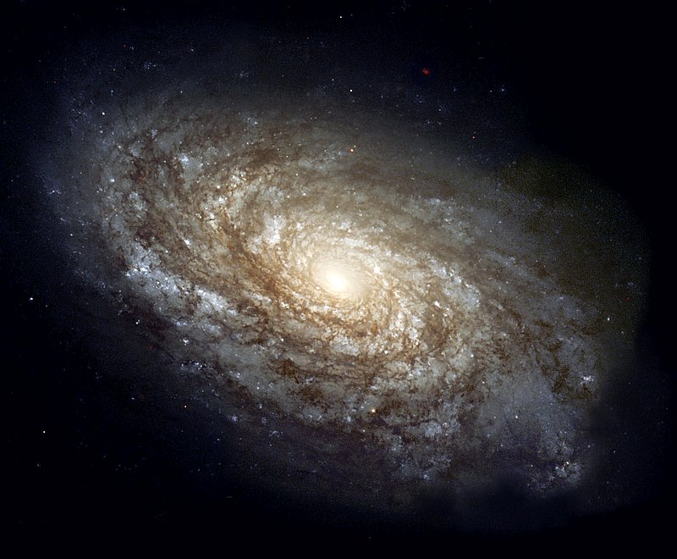Galaxy NGC 4414 photographed in 1995 using the Hubble Space Telescope. Estimated distance from earth: 60 million light-years.

Seeing the distant past?
by Andy McIntosh and Carl Wieland
Using infrared photography, a team of astronomers at the European Southern Observatory have taken pictures of what are said to be extremely distant galaxies. Their press release of 11 December 2002 assures us that ‘The resulting images reveal extremely distant galaxies, which appear at infrared wavelengths, but are barely detected in the deepest optical images acquired with the Hubble Space Telescope (HST).’¹
These galaxies are so far away from us that, according to normal theories of how light travels in space, it would have taken many billions of years for their light to have reached us. According to God’s revealed Word, the Bible, the whole universe was made only a few thousand years ago.²
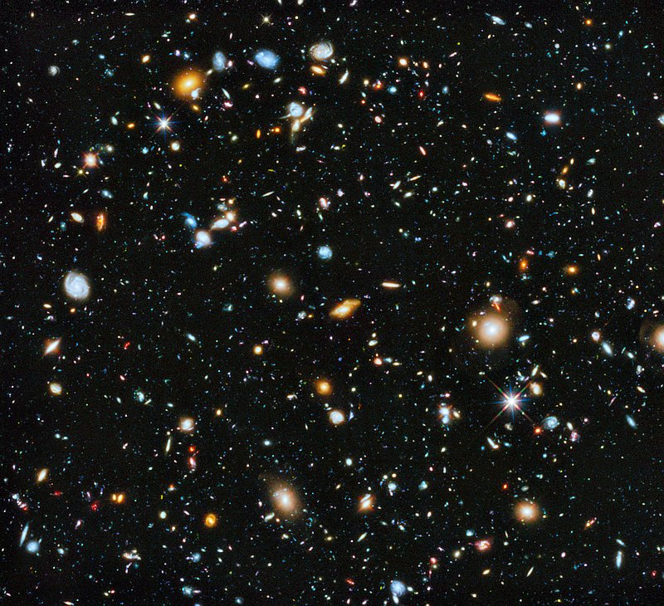Hubble’s deepest-ever view of the universe. The image is said, by NASA, to offer a view ‘ … back to the beginning of time’, and offering ‘… important clues to the understanding of the evolution of the universe’. This picture covers a view of the sky about ¹/₃₀ the diameter of the full moon and represents a typical view of galaxies over the whole sky if we could see it.
There are different models to explain how the light could have reached us in such a young universe,³ but the bottom line is as follows. If the evolutionary astronomer’s ‘big bang’ hypothesis is correct, then light from the most distant galaxies has taken the longest to reach us. Therefore, galaxies billions of light-years away would also be billions of years closer to the time of the proposed primordial ‘explosion’.⁴ Thus, since we are seeing these galaxies not as they are now, but as they were when the light left them, ‘big bang’ believers expect us to be observing them as being in much earlier stages of their alleged evolution than ones near to us.
In fact, these recent findings fit well with a Biblical viewpoint, i.e. a young universe. One of the most telling admissions in the recent article was the following:
‘… a few of [the galaxies] are clearly rather large and show spiral structure similar to that seen in very nearby galaxies [see photo opposite]. It is not obvious that current theoretical models can easily account for such galaxies having evolved to this stage so early in the life of the Universe … .’ [Ed.: according to the big bang scenario, these galaxies are less than two billion years old, in a universe that is currently said to be 13.7 billion years old.¹]

Spiraling problems
Galaxies are rotating, and the outer parts rotate more slowly than the inside. They commonly show a spiral structure, which is supposed to be the result of this rotation, starting from a simple bar structure. But this means that after a few rotations, galaxies will ‘wind themselves up’ so as to destroy the spiral structure.
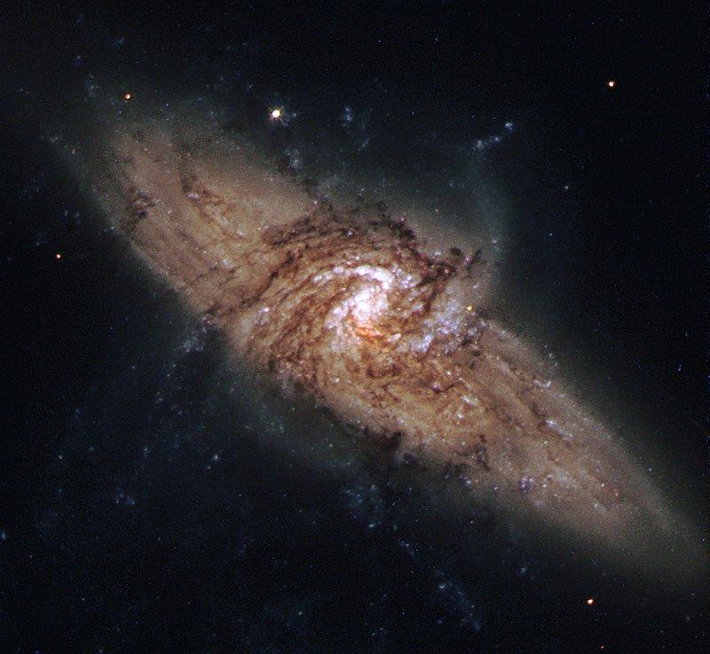A unique galaxy pair known as NGC 3314, located about 140 million light-years from earth. In this alignment a face-on spiral galaxy lies exactly in front of another larger spiral galaxy.
Both nearby galaxies and these faraway ones show the same sort of spiral structure. The evolutionist astronomer is thus ‘caught’ in two ways:
- The nearby galaxies should not be spirals anymore, because in the time that is supposed to have elapsed, they should have wound themselves up long ago, blurring the spiral appearance.^{5,6}
- These recently-observed galaxies are ultra-young (according to ‘big bang’ belief) because they are so far away. So they should not have had time to develop even the beginnings of a spiral.
The article further highlighted the confusion facing long-age astronomers by saying:
‘… in contrast to the galaxies at similar redshifts⁷ (and hence, at this early epoch) found most commonly in surveys at optical wavelengths, most of the “infrared-selected”? galaxies show relatively little visible star-forming activity. They appear in fact to have already formed most of their stars [italics added] and in quantities sufficient to account for at least half the total luminous mass of the Universe at that time. Given the time to reach this state they must clearly have formed even earlier in the life of the Universe and are thus probably amongst the ‘oldest’ galaxies now known.’¹
The results seem consistent with the notion that the Lord, who spoke the stars into existence, made the galaxies much ‘as is’. He may well have had some unwound, some not and some fully, and the variety would ‘declare the glory of God’ (Psalm 19:1). In an instant, He spread out the heavens (Isaiah 48:13) and on Day 4 of Creation Week, just as He says in His Word, ‘He made the stars also’ (Gen. 1:16).

Galaxy games

Grown up galaxies in a young universe prompt rethink of big bang ideas
by Andrew Rigg
This year stretched the imaginations of many astronomers and cosmologists. They have discovered amazing features at the outer reaches of the universe. And they cause headaches for those with blind faith in naturalistic origin theories—including a big bang about 14 billion years ago.
NASA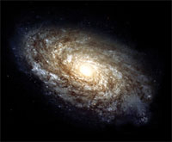Spiral Galaxy NGC 4414 as pictured by the Hubble Space Telescope. This extremely large galaxy is rich in clouds of interstellar dust. This is seen as the dark streaks silhouetted against the arms. The measured distance from Earth is about 60 million light years.
Back in January, a team of astronomers announced the discovery of a massive and distant string of galaxies. By their own dating methods, they were looking at a structure within only 2 billion years of the universe’s inception. This was much too early for such a complex structure to have evolved naturally.¹
Later this year, astronomers announced another anomalous discovery. This time, they found individual galaxies at allegedly advanced stages of galactic ‘evolution’ in a part of the sky named the ‘redshift desert’.² They used the Gemini North Telescope, with an 8-metre mirror, on the summit of Mauna Kea on the big island of Hawaii.
This area of the sky is supposed to be so old and so close to the beginning of everything that it was believed nothing as complex as a galaxy should, or could, exist there.
Under big bang assumptions, astronomers looking into the redshift desert are seeing the universe as it was 8 to 11 billion years ago, at a time when it was ‘only’ 3 to 6 billion years old. This part of the sky had not previously been widely explored. Astronomers believed it contained objects too faint and dim to study properly. However, recent advances in telescope optics have allowed astronomers to make a systematic study of the redshift desert, the Gemini Deep Deep Survey (GDDS).²
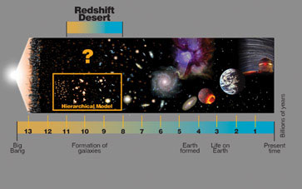Gemini Observatory, ref. 2.
What the GDDS astronomers found was totally unexpected. Where they had expected to see young, small, still-developing galaxies, they found more than 300 fully mature galaxies, just like those seen near our own galaxy, the Milky Way.
Team member Dr Karl Glazebrook from Johns Hopkins University says the find presents a huge challenge because their ‘star-forming youth is in fact long gone.’² He explained:
‘We expected to find basically zero massive galaxies beyond about 9 billion years ago, because theoretical models [based on the big bang] predict that massive galaxies form last. Instead we found highly developed galaxies that just shouldn’t have been there, but are.’³
This is a story that is sounding more and more familiar.

A creationist view
Thanks to new developments in Earth-based optical technology and orbiting telescopes such as the Hubble Space Telescope, astronomers have been able to detect fainter light from more distant objects. So they can probe the most distant reaches of space and detect objects so faint that astronomers 10 years ago did not even know they existed.
These new discoveries have shaken current theories of star and galaxy formation:
- Elements thought to ‘evolve’ within the furnaces of ancient stars over many billions of years have been found ‘only’ 2.5 billion years after the big bang, under their own dating system.⁴
- Very complex strings of galaxies, claimed to be hundreds of light-years in size, have been found at a time when only small, isolated proto-galaxies should exist.¹
- And now, massively complex galaxies and supermassive black holes (see box) have also been found too early in the evolutionary life of the universe to be explained by conventional theories.
NASA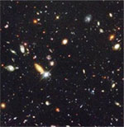

Hubble Telescope Images Defy Big Bang
Weighing over 11,000 kg at launch in 1990, this remarkable instrument has since been in low Earth orbit 600 km above the ground (above). Among the telescope’s most amazing images is this ‘deep-field’ view (right) into the farthest reaches of the universe. The picture covers an area of the sky approximately equal to that covered by a small coin viewed from 23 m (75 ft) away. Over 1,500 galaxies have identified in this image, which took the camera 10 days of constant time exposures to capture. The galaxies are four billion times fainter than that which can be seen by the human eye.
So what is the creationist response to these latest, amazing discoveries?
In Genesis 1:14–19, God tells us when He created the heavenly bodies—the planets, stars and galaxies that make up our amazing universe. The passage teaches that God commanded, ‘Let there be lights’, and the command was fulfilled with rapid formation of these objects—‘and it was so’—all within Day 4. This is further reinforced in Exodus 31:17, ‘for in six days the Lord made the heavens and the earth, and on the seventh day he abstained from work and rested’. Also, Psalm 33:6 declares, ‘by the word of the Lord were the heavens made, the starry host by the breath of his mouth.’
In the big bang model of the origin of the universe, galaxies started small. These small galaxies then began to collide. Eventually, after many billions of years, large, mature galaxies, like our own, were formed. This is called the hierarchical model of galaxy formation.
If the original heavenly bodies were created mature, then we would expect to see fully formed galaxies everywhere, even in the most distant parts of the universe. We should not be surprised to see massive strings of galaxies or to find supermassive black holes in all regions of space. In a nutshell, mature galactic structures are not a problem for creationist astronomers.
Australian physicist and creation cosmologist, Dr John Hartnett, says that these recent discoveries are very significant for a creationist understanding of the universe. ‘This has enormous significance because [the big bang astronomers] are saying they don’t see how such a structure could form so quickly according to the big bang model.’
NASA
Dr Hartnett believes that the redshift methods used to measure the distances to these objects are flawed.⁵ A growing list of evolutionary astronomers and cosmologists, such as Dr Halton Arp, agree that the big bang interpretations of the redshifts are flawed. Arp documented many pairs of objects that have greatly different redshifts, supposedly showing that they are vast distances apart and receding at hugely different speeds. Yet there is also connecting material between them, meaning that they must be the same distance away.⁶
If the distances are wrong, then an object may appear small and dim not because it is incredibly distant, but because it really is small and dim.⁷ And faulty distances mean that any theory based on them—such as the big bang—is faulty too!
As telescope technology continues to improve and astronomers are able to probe more easily the darkest depths of the universe, it is likely more and more of these big-bang–defying discoveries will arise.
These mature galaxies present a major problem for evolutionary scientists. But the underlying models have become so flexible that it is only a matter of time until they are modified to explain away such problems. However, for the biblical Christian, these discoveries, and others like them, are sound and exciting evidence in support of the biblical creation account. This account, unlike its evolutionary counterparts, is divinely inspired, so does not need any modification and change whenever new discoveries are made.

Redshift Reactions
NASA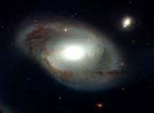
Barred spiral galaxy, NGC 4319, and the much smaller quasar, Markarian 205. Light from objects that are moving away from us is ‘stretched’ and shifted in color towards red (redshifted). According to the big bang idea, objects with greater redshifts are farther from us. From the redshifts, the quasar in the picture should be much farther away than the galaxy. But the picture on the cover of the book by the astronomer Halton Arp (right) shows matter apparently bridging from the quasar to the galaxy, suggesting that they are close. NASA’s recently-published image (below) shows no bridge between the galaxy and the quasar. Arp and other experts say that when the original NASA image is adjusted appropriately, the bridge can be seen. Some other quasar–galaxy pairs show similar bridging. Such evidence would raise huge problems for big bang cosmology.

Artist’s rendition, NASA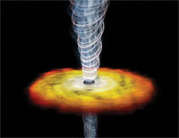

Blazars at the beginning of time
In another big-bang–defying discovery, astrophysicists from Stanford University claim to have discovered one of the biggest, most distant black holes ever found.¹
The supermassive black hole is uninspiringly dubbed Q0906+6930 after the coordinates at which it is found. Astronomers believe it exists at the centre of an extremely distant galaxy² in the direction of the northern hemisphere constellation Ursa Major (Great Bear). This galaxy is said to have an ‘active nucleus’.³
The black hole was detected by narrow jets of high-energy particles being ejected from its poles. Such jets are only visible when they are aimed exactly in the direction of the earth, meaning these types of objects—nicknamed blazars—are only rarely observed.
The black hole is believed to be more than 10 billion times the mass of our Sun and supposedly formed 12.7 billion years ago, when the universe was 1 billion years old.
The big problem presented by this blazar is its size. In big bang terms, it is just too big to have formed in the ‘mere’ billion years since the big bang itself. The scientists behind the discovery have been challenged by its implications, ‘How do you take something big enough to hold 1,000 solar systems and as heavy as all of the stars in our Milky Way galaxy put together, and quickly crunch-collapse it [in such a short period of time]?’¹ Of course size and maturity (see main article) are not a problem when the Bible, rather than man’s fallible ideas, is used as a starting point.
Some creationist cosmologists believe that the type of galaxy supposedly containing this blazar played an important role in the initial creation process. It is possible that galaxy creation on Day 4 of Creation Week involved galaxies with active nuclei, i.e. black holes.⁴

Speed of light slowing down after all?

Famous physicist makes headlines
by Carl Wieland
Headlines in several newspapers around the world have publicized a paper in Nature by a team of scientists (including the famous physicist Paul Davies) who (according to these reports) claim that ‘light has been slowing down since the creation of the universe’.¹
In view of the potential significance of the whole ‘light slowing down’ issue to creationists, it is worth reviewing it briefly here.
Well over a decade ago, CMI’s Creation magazine published very supportive articles concerning a theory by South Australian creationist Barry Setterfield, that the speed of light (‘c’) had slowed down or ‘decayed’ progressively since creation.
In one fell swoop, this theory, called ‘c decay’² (CDK) had the potential to supply two profound answers vitally important for a Biblical worldview.

The distant starlight problem
One was, if stars are really well over 6000 light years away, how could light have had time to travel from them to Earth? Two logically possible answers have serious problems:
- God created the starlight on its way: this suffers grievously from the fact that starlight also carries information about distant cosmic events. The created-in-transit theory means that the information would be ‘phony’, recording events which never happened, hence deceptive.
- The distances are deceptive: but despite some anomalies in redshift/distance correlations (see Galaxy-Quasar ‘Connection’ Defies Explanation), it’s just not possible for all stars and galaxies to be within a 6000-light-year radius—we would all fry!
But if light were billions of times faster at the beginning, and slowed down in transit, there would be no more problem.

Radiometric dates
Since most nuclear processes are mathematically related to the speed of light, a faster ‘c’ might well mean a faster rate of radioactive decay, thus explaining much of the evidence used to justify the billions of years of geological hypothesizing. In fact, top-flight creationist researchers involved with the RATE (Radioactive Isotopes and the Age of the Earth) project have found powerful evidence of speeded-up decay in the past (see their book (right). CDK might offer a mechanism.

CDK—the history of the idea
Barry Setterfield collated data of measurements of c spanning a period of about 300 years. He claimed that rather than fluctuating around both sides of the present value as measurements became more accurate, they had progressively declined from a point significantly higher than today’s value. He proposed that this decline had been exponential in nature, i.e. very rapid early on, gradually easing to stabilize at today’ value for c, just a few decades ago.³
He and Trevor Norman, a mathematician from Flinders University in South Australia, published a monograph⁴ outlining this, and answering several arguments raised against the theory. The monograph also showed how, over the past years, the measurements of the value of various constants (e.g. electron mass, Planck’s constant (h)) were varying progressively, if ever so slightly, in a ‘directional’ fashion consistent with the direction predicted by their mathematical linkage with ‘c’.
With such a bombshell, there were, not surprisingly, substantial efforts at scientific assessment and criticism. The critiques were not only from those motivated to undermine Biblical cosmology, but from leading creationist physicists. Criticism (‘iron sharpening iron’ as Proverbs 27:17 puts it) is meant to be a healthy process enhancing the search for truth in science.
The criticisms centered around two issues: the first was the validity of the statistical data itself, particularly the reliability of some of the earlier measurements of c given their large uncertainties, and the other was the consequences we should find in the present world if c has declined. This is an immensely complex area; for one thing, when c changes, so do other things, which can become mind-boggling to sort out, even for the experts.
One of the attacks concerned Einstein’s special relativity, E = mc² and the like. (If c is a billion times greater in the past, then E would be a billion billion times greater, so would not a campfire be like an atom bomb, and so on?) Critics at the time used this to mock CDK, but Setterfield answered that rest mass itself is inversely proportional to c², so that energy is still conserved. He also claimed that there is experimental evidence that the charge to mass ratio of an electron has been decreasing (supporting his claim that mass has increased as c² has decreased). But as usual, the skeptics, along with ‘progressive creationist’ (long-age) astronomer and ardent ‘big bang’ advocate, Dr Hugh Ross,⁵ kept repeating this claim as if Setterfield hadn’t thought of this and answered it. Whether one agrees with his answer or not, it was improper to ignore it (or perhaps his critics, lacking any qualifications in physics, didn’t understand it).
Critics of CDK said that accepting it would mean one would have to discard Einstein, despite all the evidence for his theory. Setterfield said (and it seems to me correctly) that all that special relativity claims in this matter is that c is constant at any point in time with respect to the observer, it does not involve any magic, canonical value for c. In other words, the actual value of c could change with time, so long as that change was consistent throughout the entire universe.⁶
Others dismissed CDK by claiming that if c had changed, the fine-structure constant (FSC, symbol α) should be different as measured using light from distant stars than from those nearby, but that this was not so.⁴ However, Setterfield’s particular theory predicted that the FSC would remain constant.⁷

A word of caution
But, intriguingly, it now turns out that the fine-structure constant is in fact slightly different in light from distant stars compared to nearby ones. In fact, this is the very reason that physicists of the stature of Davies are now prepared to challenge the assumption that light speed has always been constant. And in addition to being different from the prediction of the Setterfield theory, this research by itself does not support c-decay theory of the magnitude that Setterfield proposed. The change is billions of times too small. In fact, the newspaper hype surrounding Davies’ theory, and the quotes attributed to him, hardly seem to be justified by the Nature article itself, which is rather speculative. NB, although Setterfield predicted constant α, given the small change and tentative nature of this new discovery, by itself it is not conclusive evidence against the Setterfield theory either. See an earlier CMI response to reports of a change in α, Have fundamental constants changed, and what would it prove?
Unfortunately, despite being urged to continue to answer critics and further develop his theory within the refereed technical creationist literature, Setterfield effectively withdrew from that forum some years ago, though not from individual promotion and development of the idea, e.g. on the Web.
Well known creationist physicist, Dr Russell Humphreys (now with ICR), has long given credit to Setterfield’s challenging hypothesis for stimulating the development of his own cosmology, which seeks to answer the same question about starlight, and which is currently in favour among many creationist astronomers (see How can we see distant stars in a young Universe?). Humphreys says that he tried for over a year to find a way to get CDK to ‘work’ mathematically, but gave up when it seemed to him that so many things were changing in concert that it would be hard to detect a change in c from observations.
It’s also important to note, as we have often warned, that newspaper reports are often very different from the original paper. The actual Nature article, as shown by its accurate title, was about how the theory of black-hole thermodynamics might determine which is correct out of two possible explanations for previous work that claimed that FSC might have increased slightly and slowly over billions of years. The details are summarized in the box below. In conclusion, the authors (who are also prepared to accept that their interpretation of the data may be wrong) still believe in billions of years, and would reject the relatively rapid change in c that Setterfield proposed since they are talking about <0.001% over 6–10 billion years.
To be fair to the journalists, Davies has long been something of a publicity seeker. So he possibly didn’t mind at all that his actually quite non-descript paper was being publicized (it was actually less than a full page in total length in the ‘Brief Communications’ section, and didn’t rate a mention as a feature item), even for something peripheral to the paper.

Other c-decay ideas
Still, it is fascinating to see vindication for at least the possibility that c has changed. Whether this decline (if real) has only just ceased recently, as Setterfield proposed, or happened earlier (perhaps in a ‘one-step’ fashion), or is still going on, is another question.
Physicist Keith Wanser, a young-universe creationist and full Professor of Physics at California State University, Fullerton, told Creation magazine in 1999 that he was open to the idea of changing c (see God and the Electron⁸). He said:
‘I don’t go along with Barry’s statements on this; he’s well-meaning but in my opinion he’s made a lot of rash assumptions ... and there’s a misunderstanding [of many of the consequences of changing c].’
But Wanser, also said:
‘there are other reasons to believe that the speed of light is changing, or has changed in the past, that have nothing to do with the Setterfield theory.’
The interview also quoted a 1999 New Scientist cover story two years ago, which also proposed the ‘heresy’ of c-decay.⁹ (More recent New Scientist articles have reported on how it seems to be acceptable to propose c-decay to try to solve another well-known difficulty of the big bang theory, called the horizon problem. That is, the cosmic microwave radiation indicates that space is the same temperature everywhere, indicating a common influence. But no connection between distant regions would be possible, even in the assumed time since the alleged ‘big bang’, because of the ‘horizon’ of the finite speed of light. As an ad hoc solution to this problem, Alan Guth proposed that the universe once underwent a period of very rapid growth, called ‘inflation’. But now it seems that even this has its own horizon problem. So now some physicists have proposed that the speed of light was much faster in the past, which would allow the ‘horizon’ to be much further away and thus accommodate the universe’ thermal equilibrium.¹⁰ Note that these other proposals even have c much faster than in the Setterfield concept.)
Whether Setterfield is truly vindicated remains to be seen; the process would be greatly helped by further scientific debate of the actual issues in Journal of Creation or the CRSQ. In the absence of such involvement by skilled proponents of the theory, CMI cannot take a strong stand. In fact, in our publications over the last few years, we have tended to strongly favour Humphreys’ relativistic white hole cosmology, though always pointing out, along with Humphreys himself, that it was just one alternative model, and not ‘absolute truth’.
It is clear, though, that the issue is so complex, that one or two pronouncements of ‘certainty’ by a physicist or two, whether creationist or evolutionist, should not be taken as the death knell of the notion or any aspects of it—nor as final proof of it.

The irony of bias
It is truly ironic to look back at the time when some creationists were actively putting forward CDK as a profoundly important hypothesis. The anticreationists, both the anti-theists and their compromising churchian allies, launched their attacks with glee. Skeptics around the world seldom failed to have audiences in fits of laughter at the ‘ridiculous’ notion that what they labeled as a ‘certain cornerstone of modern physics’, the alleged constancy through time of the value of c, was wrong. No matter what comes of his notion as a whole, no matter even whether c has actually changed or not, in that sense at least, thanks to Paul Davies, Setterfield (and those, like ourselves, who supported his pioneering efforts) has already had the last laugh.

The real issue
Christians worried about the ‘starlight travel-time’ issue have seen a number of theories put forward to try to solve it, including CDK. For instance, the relativistic white-hole cosmology (see video, right) and even the two different conventions of calculated v. observed time.¹¹ Which of these is right? Maybe none. I often say to enquirers, after outlining the encouraging advances made by some of these ideas, something like the following:
‘I don’t know for sure how God did it, but I know that I for one would hate to stand in front of the Creator of the Universe at a future point and say:
”Lord, I couldn’t believe your plain words about origins, just because I couldn’t figure out, with my pea-sized intelligence, how you managed to pull off the trick of making a universe that was both very young and very large.”’
I believe we need to understand, as most physicists really do, how immensely little is yet known about such major issues. What if Humphreys is right, for instance, and the answer lies in the general relativistic distortion (by gravity) of time itself in an expanded (by God who ‘stretched out the heavens’ as Scripture says repeatedly) bounded universe? Would not the world have laughed if such notions (as time running differently under different gravity influences, for instance) had first been put forward by modern Bible-believers? They would have been seen as ad hoc inventions, but they have been experimentally tested.
This ‘secular CDK’ announcement, by one of the biggest names in physics, should really be an antidote to the confident arrogance of long-age big-bangers. So should the recent landmark Journal of Creation paper by Humphreys showing observationally that we are in fact close to the centre of a bounded universe (download PDF file Our galaxy is the centre of the universe, ‘quantized’ red shifts Show).
People need to be aware just how abstract, shaky and prone to revision the findings of modern cosmology really are. To quote Prof. Wanser again:
‘The sad thing is that the public is so overawed by these things [big bang and long-age cosmologies], just because there is complex maths involved. They don’t realize how much philosophical speculation and imagination is injected along with the maths—these are really stories that are made up.’¹²
All in all, it’s an exciting time to be a Genesis creationist. But then, it’s always been an exciting time to take God at His Word.

What was Davies’ paper really about?
The gist of it is:
- Already known: the fine structure constant α = 2πe²/hc, where e is the electronic charge and h is Planck’s Constant. Last year, there was a claim that α is increasing over time [as CMI reported in Have fundamental constants changed, and what would it prove?].
- So this increase in α could be due to increasing e or decreasing c (CDK). But as mentioned, this conflicts with Setterfield’s model that has α invariant with varying c because it’s h that varies inversely to c.
- The Second Law of Thermodynamics is in force. The entropy of a black hole increases with area of its event horizon (that’s if the standard formula applies with either varying c or e). Therefore, the area cannot decrease unless the black hole’s environment has a corresponding entropy increase.
- The key point of this theoretical ‘brief communication’: an increase in e would mean a reduction of a black hole’s area, which would seem to violate the Second Law under the current formula. Increasing e could also lead to an increase of a black hole’s electric charge above a threshold value where the event horizon disappears and we are left with a naked singularity, and this would violate what’s known as the cosmic censorship hypothesis. Davies et al. conclude:
Our arguments, although only suggestive, indicate that theories in which e increases with time are at risk of violating both the second law and the cosmic censorship hypothesis.
- But a decrease in c over time would lead to an increase in a black hole’s area, which is in line with the Second Law. So by a process of elimination based on this theory about black hole thermodynamics (not on any new data), a tiny decrease of c is the right explanation for the tiny increase that was previously claimed for α over time.

Addendum: Physicist Dr Russell Humphreys comments:
‘The article on the [CMI] Web site is well balanced. Paul Davies’ Nature article itself falls far short of the hype, which is much ado about nearly nothing. General Relativity has had a variable speed of light ever since 1917. For the past six years, the physics journals have had a steady trickle of variable-c theories, including some by Davies. His latest article is only peripherally about a variable c. So why all the fuss?’

‘Star witnesses’ to a young creation
by Don Batten
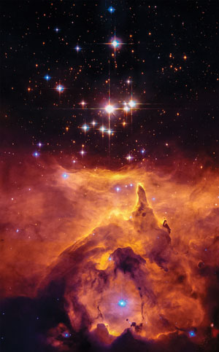

We cannot use science to prove the age of the universe because science can only deal with what is observable now. We can measure the rates of all manner of things in the present. However, to use these as ‘clocks’ to estimate ages, we have to assume a history, which in turn depends upon our beliefs about where we came from. The Bible gives us an eyewitness record of what happened, the order, and the timeframe, which ‘science’ cannot tell us.
Yet blue stars abound in spiral galaxies, including our Milky Way.
Nevertheless, today’s widespread belief in a very old universe fails to account for many ‘clocks’ that indicate a far younger age. Here are two.¹

Blue stars in galaxies
Blue stars are the biggest and brightest of all ‘main sequence’ stars, but this means they burn up their nuclear fuel very fast. Indeed, they burn so fast that the biggest ones could not last more than a million years, and the smallest around 10 million years. Yet blue stars abound in spiral galaxies, including our Milky Way. This suggests that these galaxies cannot be even one million years old. This problem for the belief that the galaxies are billions of years old is ‘solved’ by assuming the blue stars formed more recently than the rest of the galaxy. However, no one has observed such star formation and there is not even a viable mechanism for it to happen.²

Neutron stars in globular clusters
Many globular clusters should have emptied [of fast neutron stars] in a few thousand years
Globular clusters are compact, ball-shaped groups of stars that orbit the centre of a galaxy. They supposedly contain ‘very old’ stars. The secular big bang story has great difficulty explaining them.³ Astronomers have seen many fast-moving neutron stars in globular clusters. These are thought to arise from supernovas (exploding stars) within the cluster, where a neutron star is created that is ‘kicked’ out at very high speed. With the compact sizes of globular clusters and the high speed of the neutron stars, all neutron stars should be ejected from such clusters in less than two million years. Many globular clusters should have emptied in a few thousand years. A major study of this so-called ‘retention problem’ called it a “long-standing mystery”.⁴ These observations, too, are consistent with a young age of the universe.

